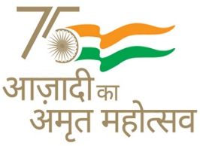
KENDRIYA VIDYALAYA SANGATHAN AHMEDABAD REGION
GRADED WORKSHEET
CLASS : 4 SUBJECT: EVS LEVEL : 1
Concept : Travel Max. Marks : 10
Name of the KV : _________________________________________________________
Name of the Student : ___________________________Roll No. ______ Section: _____
Date : _______________ Marks Obtained: _________ Sign of Teacher____________
Answer the following:
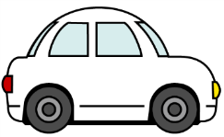
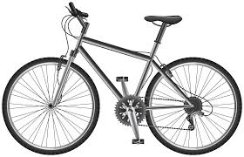
- Name the following vehicles that you use to go your nearby places.

___________ ___________
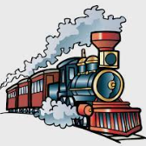
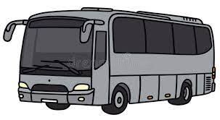
- Name these two vehicles which are used to travel to a long distance.

___________ ___________
- Name the following vehicles in which animals are used.
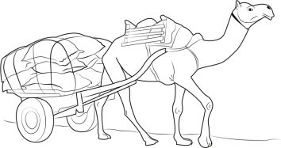
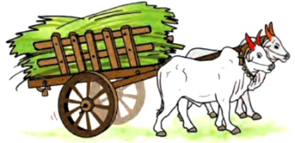

___________ ____________
- Which of the following vehicle you can use to go school by a road?
- Bicycle (b) boat (c) Aeroplane (d) None of the above
- Which of the following vehicle you can use to go to school and it has only three wheels?
- Scooter (b) Auto-rickshaws (c) Car (d) Bus

- Which of the following we cannot use if we want to cross a river?
- A boat (b) A bridge (c) A trolley (d) A motorcycle

- Give the name of the vehicle that you use to go to school. ………………………
- Make a drawing or paste a picture of the vehicle by which your best friend goes to school.

- Name the state in which your school is located. ………..……………..

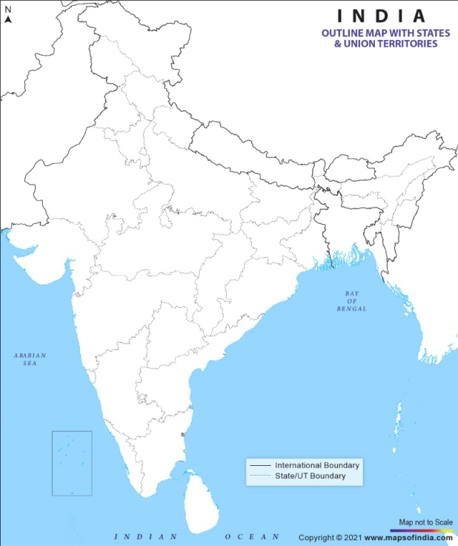
- Colour the state in which your school is located in the given map.

KENDRIYA VIDYALAYA SANGATHAN AHMEDABAD REGION
GRADED WORKSHEET
CLASS : 4 SUBJECT: EVS LEVEL : 2
Concept : Travel Max. Marks : 10
Name of the KV : _________________________________________________________
Name of the Student : ___________________________Roll No. ______ Section: _____
Date : _______________ Marks Obtained: _________ Sign of Teacher____________
Answer the following:
1. Which of the following vehicle will be helpful to you to cross a river? ……………………
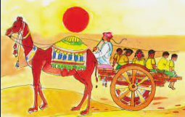
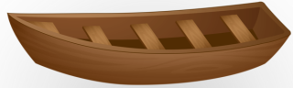
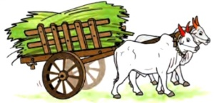

(a)Bullock-cart (b) car (c) Boat (d) A camel-cart
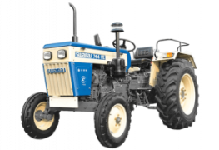
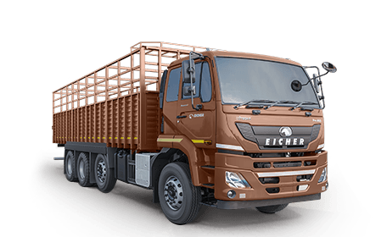
2. If you do not have a boat, which of the following will help you to cross a river?
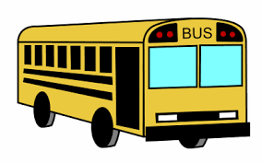
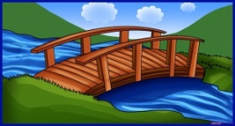

- A truck (b) A tractor (c) a bridge (d) Bus
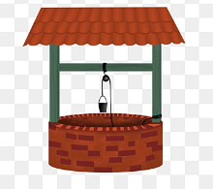
3. Which of the following is not a bridge?................
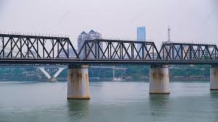
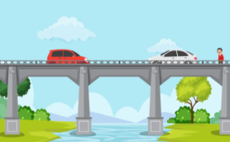
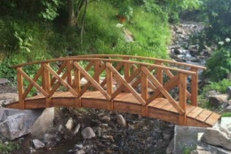

(a) (b) (c) (d)
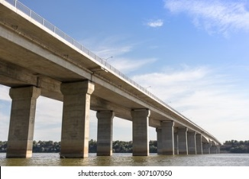
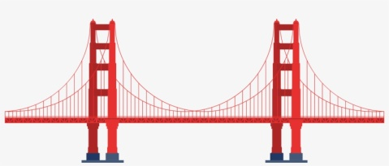
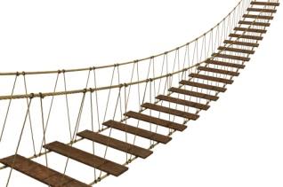
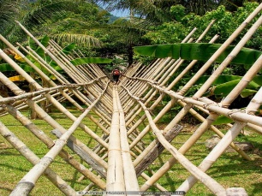
4. Which of the following is a bamboo bridge? .............

(a) (b) (c) (d)

5. Which of the following is a trolley bridge or a rope-way? ……………..
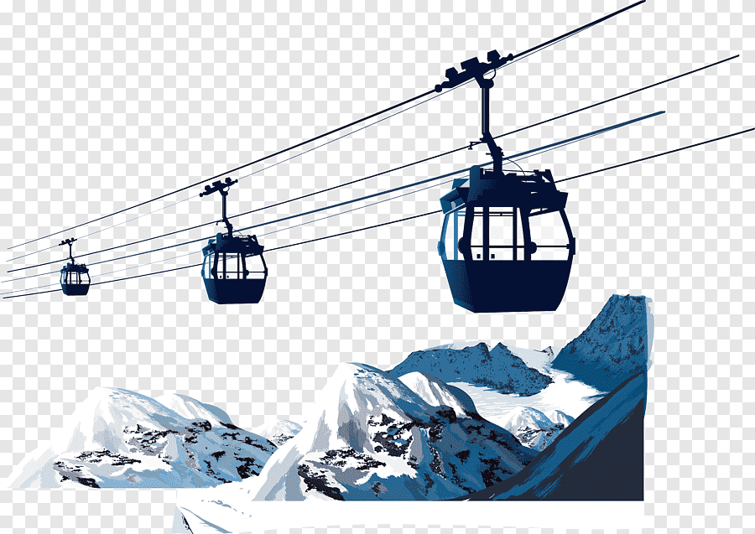
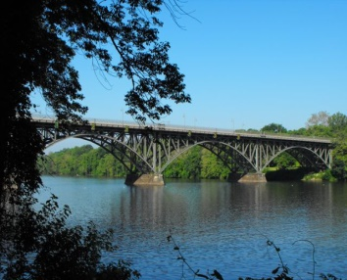
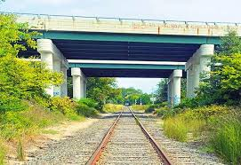
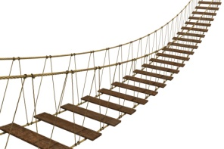

(a) (b) (c) (d)
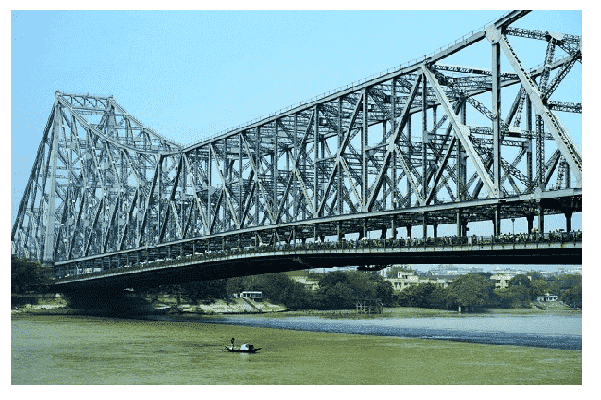
6. This is a picture of the famous Howrah Bridge.
Which kind of bridge is it?
- Bamboo (b) Iron
- Cement (d)Wooden
7. Different materials are used to build different types of bridges. Match the type of bridge in Column A with the material it is made of in Column B by drawing arrows.
Column A Column B
(i) Trolley bridge (a) Bricks, iron rods and cement
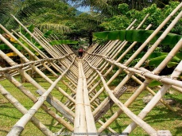
(ii) Bamboo bridge (b) Wood and iron rope
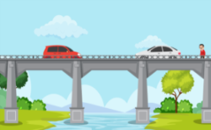
(iii) Cement bridge (c) Iron
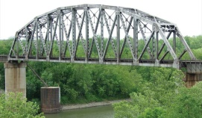
(iv) Iron bridge (d) Bamboo and rope
A | C | B | V | T | Y | B | L
I | T | R | N | F | U | S | T
R | F | I | K | U | R | A | E
O | D | C | E | M | E | N | T
N | A | K | W | O | O | D | H
K | E | S | Z | L | G | L | K
8. Find the names of the different materials that are used to make a cement bridge from the maze given below:
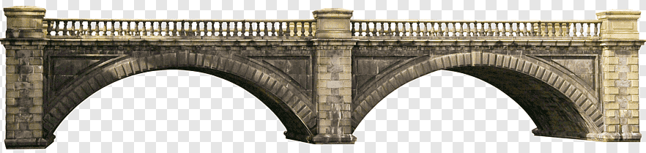
__________________
__________________
__________________
__________________
KENDRIYA VIDYALAYA SANGATHAN AHMEDABAD REGION
GRADED WORKSHEET
CLASS : 4 SUBJECT: EVS LEVEL : 3
Concept : Travel Max. Marks : 10
Name of the KV : _________________________________________________________
Name of the Student : ___________________________Roll No. ______ Section: _____
Date : _______________ Marks Obtained: _________ Sign of Teacher____________
- Answer the following:
1. In which kind of places is this vehicle commonly seen?
………………………………………………………………………………………………
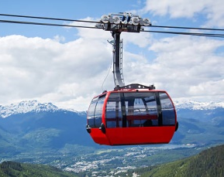
2. In which kind places is this means of transport useful?
…………………………………………………………………………………………
…………………………………………………………………………………………
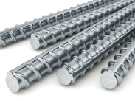
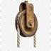
3. Which of the following thing helps a trolley to move across the iron rope?
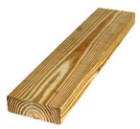

- Pulley (b) Screw (c) iron rod (d) wooden plank
4. Name four things which contain a pulley.
……………………….. …………………………
……………………….. …………………………
5. What are the differences can you find between a bamboo bridge and a cement bridge?

Bamboo Bridge | Cement Bridge
1. | 1.
2. | 2.
3. | 3.
4. | 4.

6. This is a picture of one special vehicle. Look at the picture and answer the questions that follow:
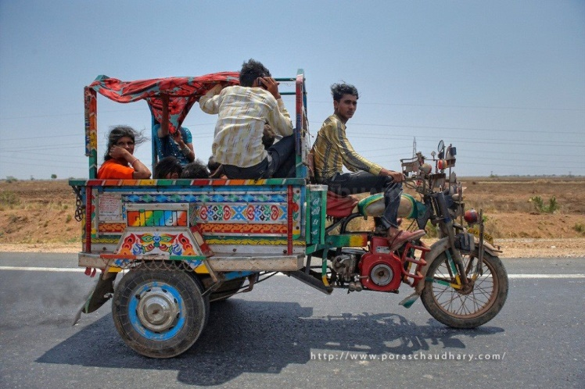
- What is the name of this vehicle?
………………………………………………..
- In which part of India is this vehicle found the most?
- West Bengal (c) Kerala
- Gujarat (d) Assam
- The front part of this vehicle looks like….
- A bicycle (b) A car
- A Motorcycle (d) A bus
- The back of this vehicle is made out of…..
- Wooden planks (b) Rubber
- Iron rods (d) None of the above
- What sound does it make when it runs?
- Gharr… gharr… gharr… (b) Phut…phut…phut…
- Khud…khud…khud (d) None of the above

KENDRIYA VIDYALAYA SANGATHAN AHMEDABAD REGION
GRADED WORKSHEET
CLASS : 4 SUBJECT: EVS LEVEL : 4
Concept : Travel Max. Marks : 10
Name of the KV : _________________________________________________________
Name of the Student : ___________________________Roll No. ______ Section: _____
Date : _______________ Marks Obtained: _________ Sign of Teacher____________
Answer the following:
- Which of the following work cannot be done by a pulley?
(a) Helping a trolley move across a river
(b) Helping a blind man cross the road
(c) Taking out water form a well
(d) Lifting a vehicle
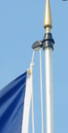
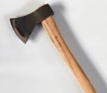
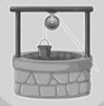
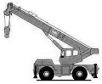
- Encircle the odd one out.

- Crane (b) well (c) flagpole (d) axe
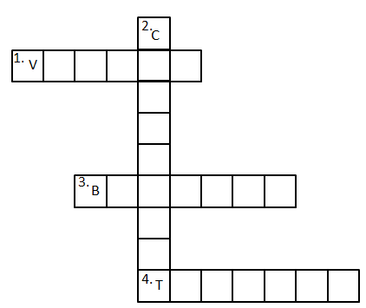
- Complete the following puzzle by given clues.
Across: Down:
2. A vehicle which is used in desert area.
1. The wooden boat used in some part of Kerala

3. The vehicle by which children can travel by their own

4. A wooden or Iron box attached with a rope to cross a river in hilly area

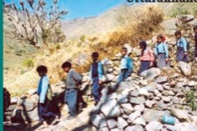
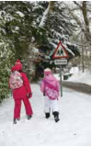
- Compare the difficulties between going to school as shown in Picture 1 and Picture 2.

Picture-2
Picture-1

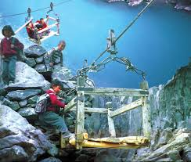(5) In different parts of India students use different ways to reach the school. Look at the map and locate and name the states:
Using trolley

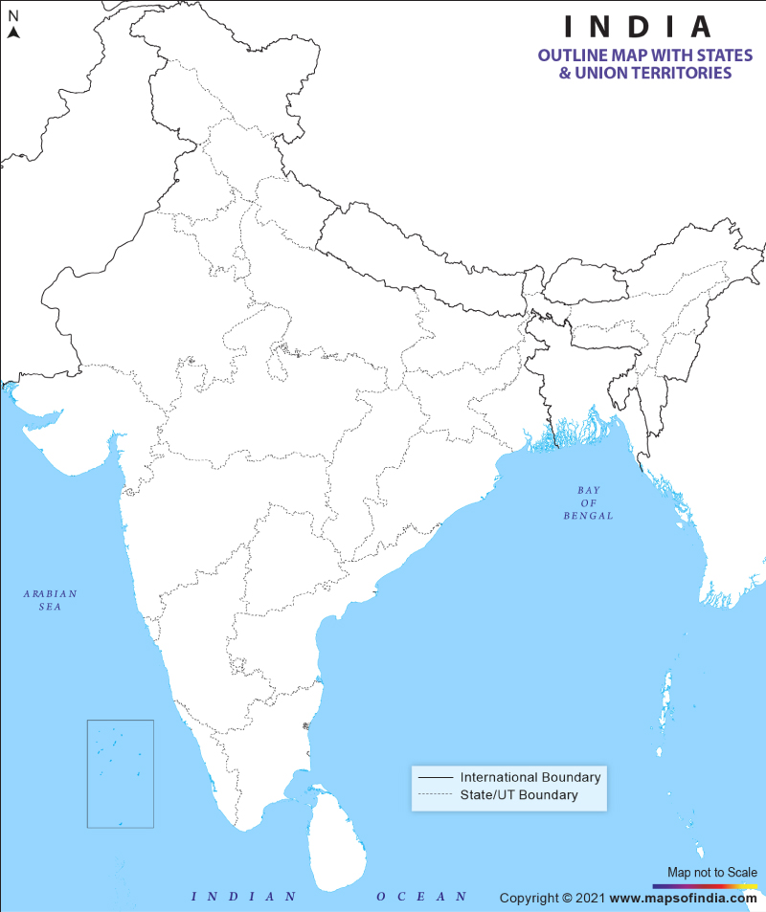
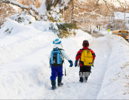
Walking through snow

Camel-cart
Walking through rocky paths
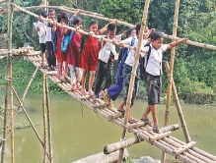
Walking on a Bamboo Bridge

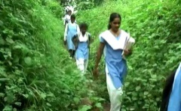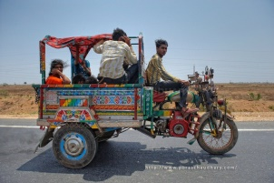
Crossing a thick forest
Jugad

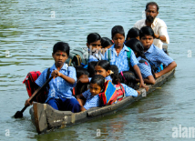
Vallam

