KENDRIYA VIDYALAYA SANGATHAN AHMEDABAD REGION
GRADED WORKSHEET
CLASS : 4 SUBJECT: LEVEL : 1
Concept : Family and Friends Max. Marks : 10
Name of the KV : _________________________________________________________
Name of the Student : ___________________ Roll No. ______ Section: _____
Date : _______________ Marks Obtained: _________ Sign of Teacher____________
- Answer the following:
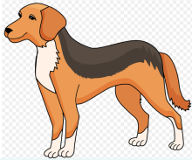
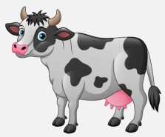
- Name the following animals that you see around you.

___________ ___________
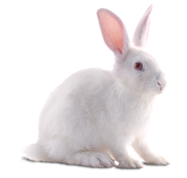
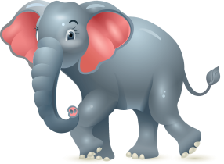
- Name these two animals which have big ears.

__________ ___________
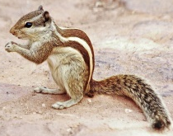
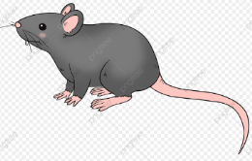
- Name the following animals which have small ears.

___________ ___________
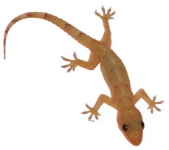
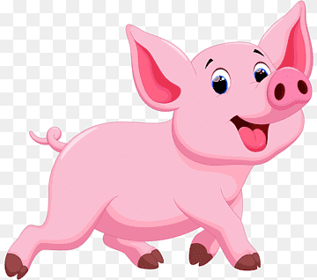
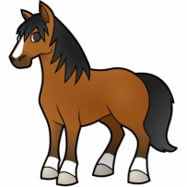
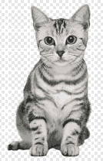
- Which of the following animals have tiny holes instead of ears?

- cat (b) horse (c)Lizard (d) Pig

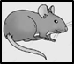
- Which of the following animals lays eggs?
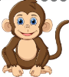
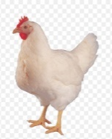

(a) Monkey (b) Hen (c) Dog (d) Rat

- Which of the following animal give birth to babies? ………………

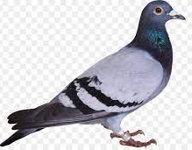
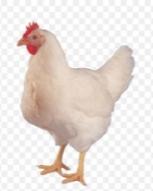
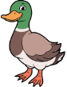

(a) (b) (c) (d)

- Write True or False:
All the animals have same kind of ears. ……………………

- Write the names of two animals which have hair on their skin.

……………………………… …………………………………….

- Write the names of two animals which have feathers on their skin.

……………………………… …………………………………….

- Give the name of our national animal.

…..………………………................................

KENDRIYA VIDYALAYA SANGATHAN AHMEDABAD REGION
GRADED WORKSHEET
CLASS : 4 SUBJECT: LEVEL : 2
Concept : Family and Friends Max. Marks : 10
Name of the KV : _________________________________________________________
Name of the Student : ___________________ Roll No. ______ Section: _____
Date : _______________ Marks Obtained: _________ Sign of Teacher____________
Answer the following:
1. Observe the following pictures and name them. Do they have visible ears?
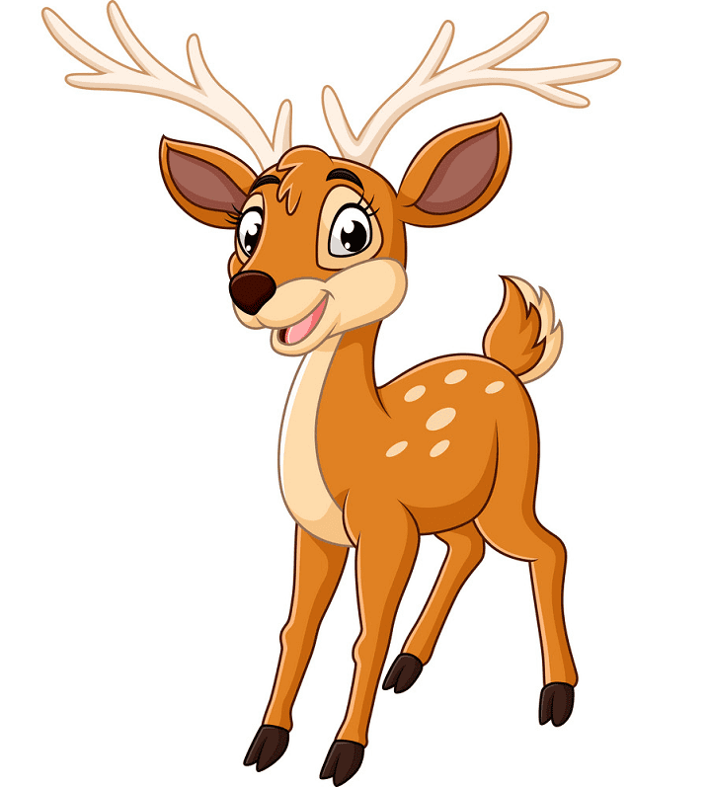
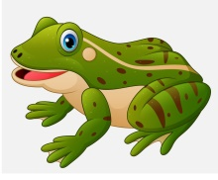
Tick () Yes or No .

(a) …………………… YES /NO (b) …………………………. Yes / No
2. Give the names of the following animals by observing their ears.
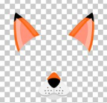

………………….. ……………………
3. Which of the following does not have feathers or hair on its skin?
Write its name. ……………………
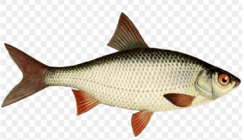
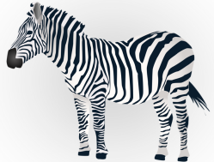
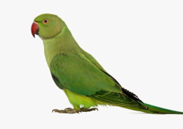
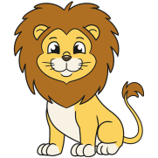

- (b) (c) (d)
4. Find the odd one out.
- Lizard Turtle Frog Rat Crocodile
- Hen Duck Parrot Crow Horse

5. Encircle the names of the animals which give birth to babies with red colour.

Lion Snake Horse Pigeon

6. Encircle the names of the animals which lay eggs with green colour.

Peacock Sheep Frog Fox
7. Match the following animals with the types of their ears:
- Elephant (i) Ears on both sides of its head

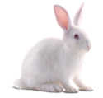
- Rabbit (ii) holes in place of ears

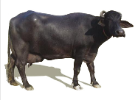
- Buffalo (iii) Big ears like a fan
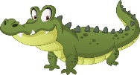
- Crocodile (iv) Ears on the top of the head

8. Birds do not have external (Visible ) ears. How do they hear? Write your answer.
…………………………………………………………………………………………………………………………….
…………………………………………………………………………………………………………………………….
…………………………………………………………………………………………………………………………….
…………………………………………………………………………………………………………………………….

KENDRIYA VIDYALAYA SANGATHAN AHMEDABAD REGION
GRADED WORKSHEET
CLASS : 4 SUBJECT: LEVEL : 3
Concept : Family and Friends Max. Marks : 10
Name of the KV : _________________________________________________________
Name of the Student : ___________________ Roll No. ______ Section: _____
Date : _______________ Marks Obtained: _________ Sign of Teacher____________
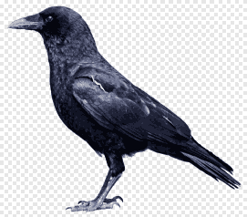
- Answer the following:

1. Name this animal which has tiny holes on the both side of its
head to hear.
………………………………………………………………………………………………

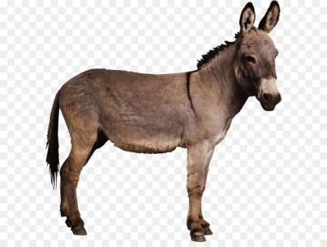
2. Which is not True about this picture?
(a)The donkey has ears which cannot be seen.
(b) The donkey has ears on the top of its head
(c) The donkey has ears on the sides of its head
(d) Both (a) and (c)

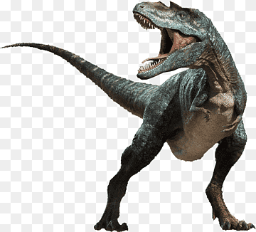
3. Now where do we see dinosaurs?
(a) Only in forests
(b) Only in the zoo
(c) In films and pictures
(d) None of these

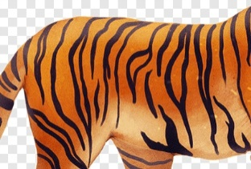
4. Identify the following animals by its skin.
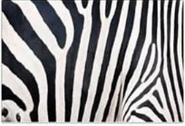

……………………….. …………………………
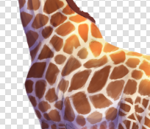

……………………….. …………………………
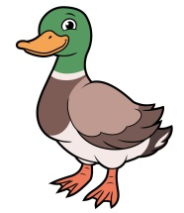
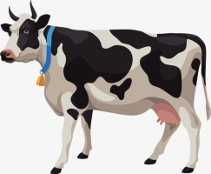
5. What are the differences that can you find between these two animals?

Cow | Duck
1. | 1.
2. | 2.
6. Look at the picture and answer the questions that follow:
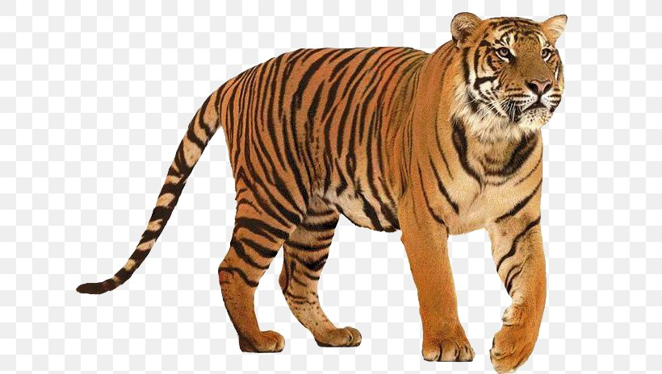
- What is the name of this animal?
………………………………………………..
- Write True or False :
It is our National animal. ……………..
- In which State of India is this animal found the most?
- West Bengal (c) Madhya Pradesh
- Gujarat (d) Uttarakhand
- What does this animal have on his body?
- white spots (c) Black stripes
- Black spots (d) White stripes
- Does this animal give birth to babies? Yes / No ………….

KENDRIYA VIDYALAYA SANGATHAN AHMEDABAD REGION
GRADED WORKSHEET
CLASS : 4 SUBJECT: LEVEL : 4
Concept : Family and Friends Max. Marks : 10
Name of the KV : _________________________________________________________
Name of the Student : ___________________ Roll No. ______ Section: _____
Date : _______________ Marks Obtained: _________ Sign of Teacher____________

- Answer the following:

- Deepak loves to visit the zoo. Which of these animals will Deepak NOT find in the zoo?
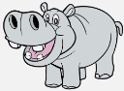
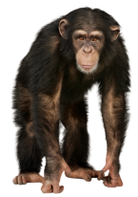
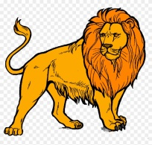

- Hippopotamus (b)Monkey (c) Lion (d) Dinosour

- A student wrote the following in her notebook. Which animal could she probably be writing about? ………….
- It has four legs.
- It has tiny holes on the both the side of its head.
- It eats insects.
- It can crawl on the wall.
(a) Rabbit
(b) Frog
(c) Dog
(d) Lizard

- How does a snake hear?
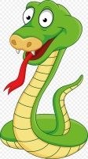
………………………………………………………………………………………………………………………
………………………………………………………………………………………………………………………

- The names of some animals are hidden in the given maze. Find them and put them in the proper column.
Has hair on skin
Has feathers on skin

A | F | K | H | E | N | R | Y | C
S | O | M | T | S | A | P | U | R
D | X | B | L | C | F | A | M | O
L | N | S | P | A | R | R | O | W
I | T | V | I | M | L | R | D | A
O | R | I | G | E | Y | O | D | P
N | S | P | J | L | O | T | N | T

(5) What do you mean by endangered animals? What are the reasons for the animals becoming endangered?
………………………………………………………………………………………………………………………………………………………………………………………………………………………………………………………………………………………………………………………………………………………………………………………………………………………………………………………………………………………………………………………………………………………………………………………………………………………………………………………………………………………………………………………………………………………………………………………………………………………………………………………………………………………………………………………………………………………………………………………………………………………………………………………………………………………………………………………………………………………………………………………………………………………………………………………………………………………………………………………………………………………………………………………………………………………………………………………………………………………………………………………………………………………………………………………………………………………………………………………………………………………………………………………………………………………………………………………………………………………………

