 **KENDRIYA VIDYALAYA SANGATHAN AHMEDABAD REGION**

**GRADED WORKSHEET**

**CLASS : 4 SUBJECT: EVS LEVEL : 1**

**Concept : Family And Friends Max. Marks : 10**

**Name of the KV : _________________________________________________________**

**Name of the Student : ___________________________Roll No. ______ Section: _____**

**Date : _______________ Marks Obtained: _________ Sign of Teacher____________**

* **Answer the following:**

1. Name these plants that are generally found around your house.

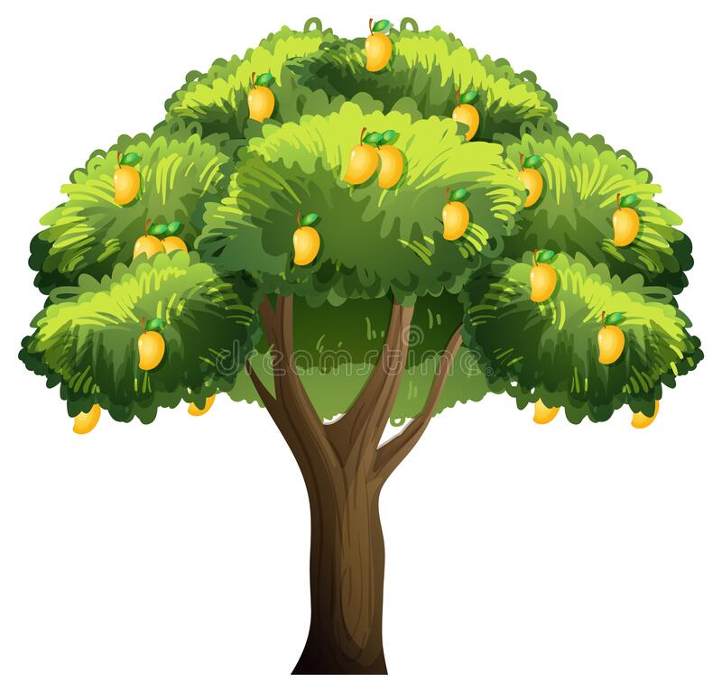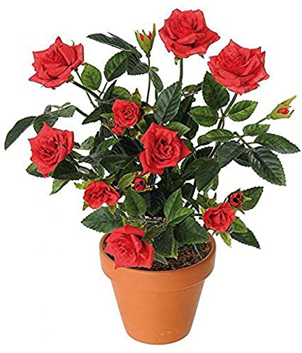

……………………… ……………………..

1. Name these animals that are kept to get milk and other product.

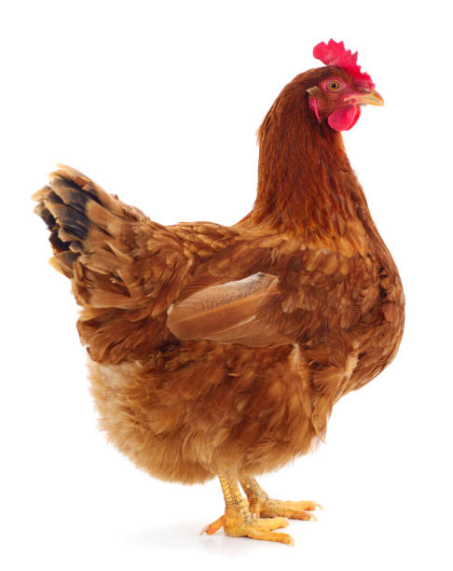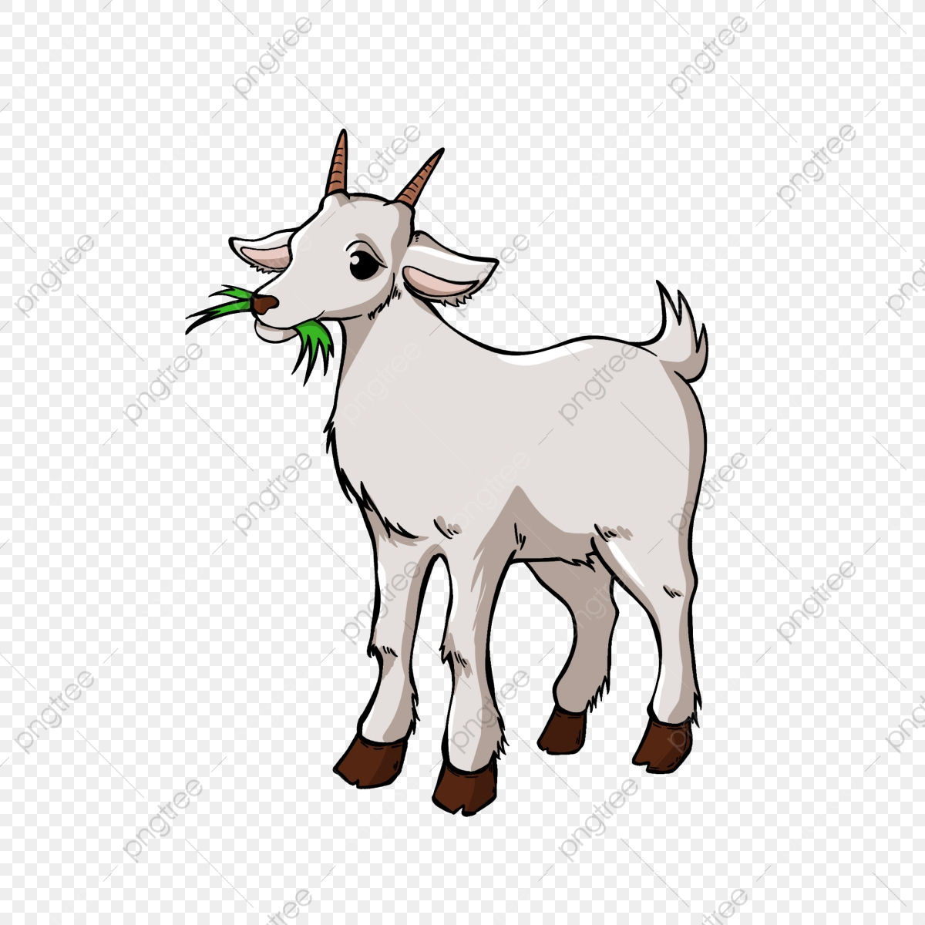

…………………… ……………………

1. Name these things that we get from plants.

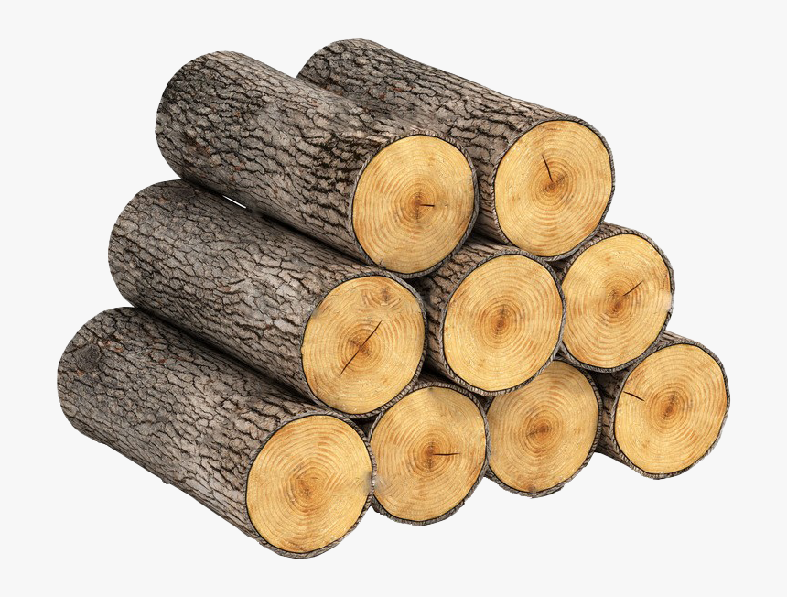

………………………………. ……………………………

1. Name these things that we get from animals.

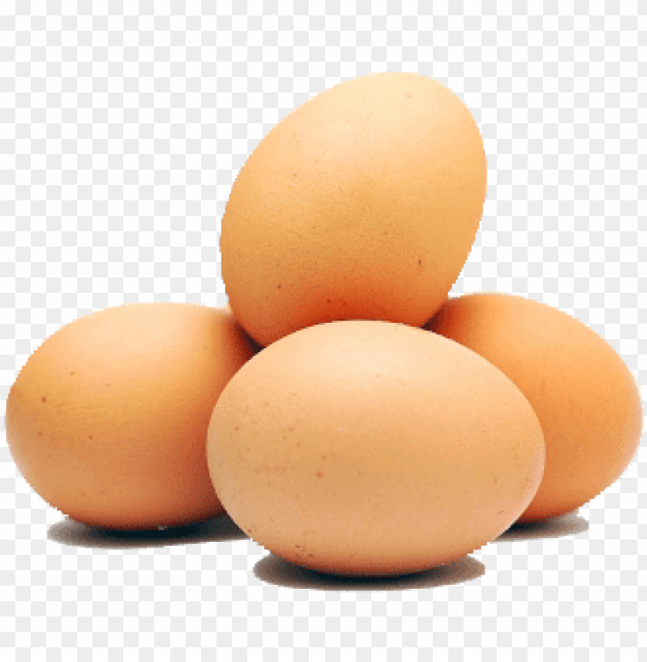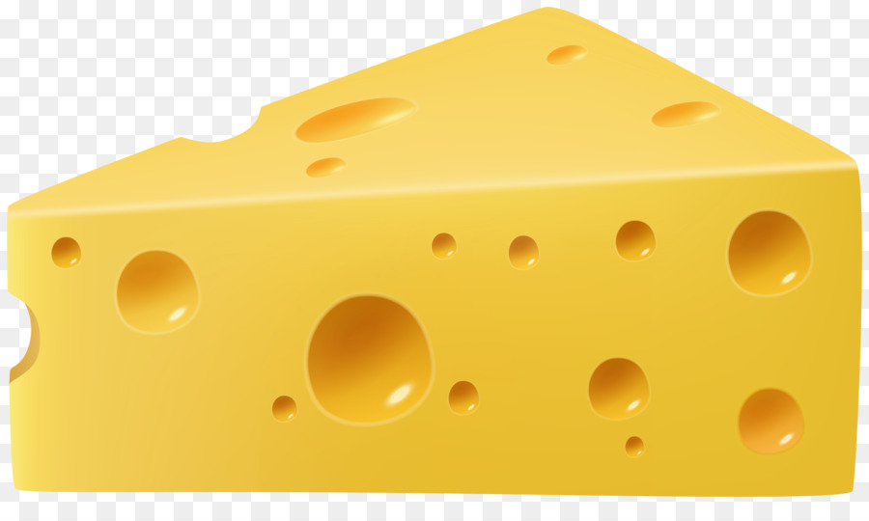

……………………………... ……………………..

1. Which of the following thing is made from plants?

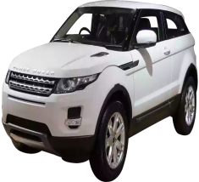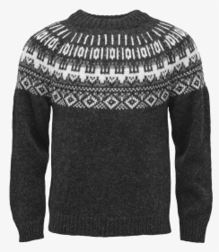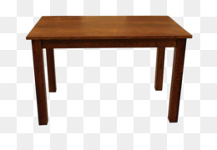

1. Car (b) Sweater (c) wooden table (d) Plastic bottle
2. Which of the following thing do we get from animals?
3. Wool (b) Honey (c) Milk (d) All of the above
4. Name any two plants that give us fruits.

………………………. …………………………….

1. Which plants have a great medicinal value?

………………………… ……………………………….

1. Why are the trees planted along the road side?

………………………………………………………………………………………………………………………………………

………………………………………………………………………………………………………………………………………

1. Locate your state in the given map of India and write the names of two trees that found commonly in your area.

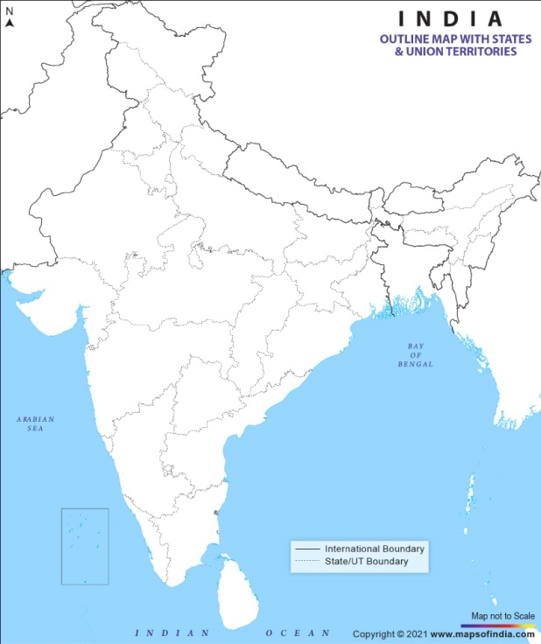 ………………………………………

………………………………………

 **KENDRIYA VIDYALAYA SANGATHAN AHMEDABAD REGION**

**GRADED WORKSHEET**

**CLASS : 4 SUBJECT: EVS LEVEL : 2**

**Concept : Family And Friends Max. Marks : 10**

**Name of the KV : _________________________________________________________**

**Name of the Student : ___________________________Roll No. ______ Section: _____**

**Date : _______________ Marks Obtained: _________ Sign of Teacher____________**

* **Answer the following:**

**1. Name this tree. It’s our national tree.**

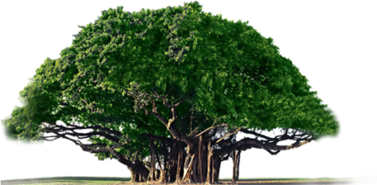

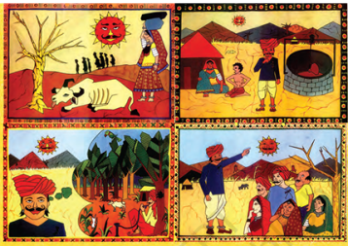………………………

**2. Write True or False:**

The story of Amrita is a true story. …………………..

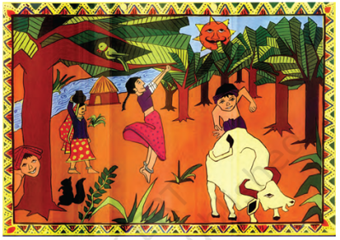**3. Children of Amrita’s village played for hours….**

1. hop skotch and gulli-danda
2. inside their homes
3. in the shade of the trees
4. in the village playground

**4. The King wanted the trees to be cut because**…

(a) the wood was needed for his palace

(b) they were very old

(c) all their leaves had fallen

(d) the villagers were his enemies

**5. The most common tree that grew in Amrita's village was the ............... tree.**

(a) Neem (b) Khejadi (c) Peepal (d) None of these

**6. Encircle the odd one out:**

1. Khejadi (b) cactus (c) Date palms (d) Banana

**7. Complete the crossword puzzle using the given clues:**

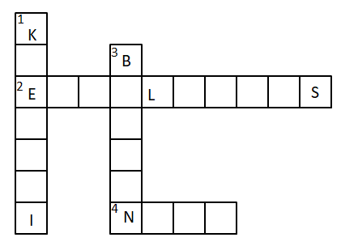

DOWN 🡫

1. This tree generally found in desert area

3. This is our national tree

ACROSS 🡪

2. This tree gives us a long timber and oil

4. This tree has bitter taste and high medicinal values

8. Where is Khejadli village situated? Colour that state in the given map of India.

………………………………………………………………………………………………………………………………………

………………………………………………………………………………………………………………………………………



 **KENDRIYA VIDYALAYA SANGATHAN AHMEDABAD REGION**

**GRADED WORKSHEET**

**CLASS : 4 SUBJECT: EVS LEVEL : 3**

**Concept : Family And Friends Max. Marks : 10**

**Name of the KV : _________________________________________________________**

**Name of the Student : ___________________________Roll No. ______ Section: _____**

**Date : _______________ Marks Obtained: _________ Sign of Teacher____________**

* **Answer the following:**

1. **Name any two plants that we eat as food.**

……………………… …………………………….

1. 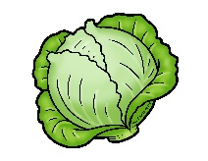**Here are some vegetables. Which part of it do we eat?**

……………………….. ……………………..

1. **Which of the following are unwanted plants that grow without being planted?**
2. Seeds (b) weeds (c) apple trees (d) Mango trees
3. **Make a list of things that we get from plants and write them in the boxes.**

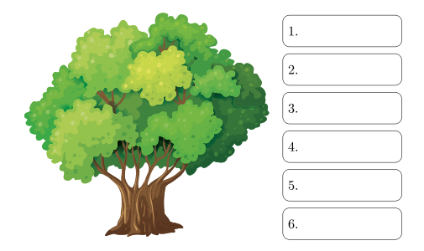

1. **Why do people cut trees for?**

………………………………………………………………………………………………………………………………………

………………………………………………………………………………………………………………………………………

1. **“Khejadi is a useful tree.” - Write five sentences to support these statement.**

………………………………………………………………………………………………………………………………………

………………………………………………………………………………………………………………………………………

………………………………………………………………………………………………………………………………………

………………………………………………………………………………………………………………………………………

………………………………………………………………………………………………………………………………………

………………………………………………………………………………………………………………………………………

 **KENDRIYA VIDYALAYA SANGATHAN AHMEDABAD REGION**

**GRADED WORKSHEET**

**CLASS : 4 SUBJECT: EVS LEVEL : 4**

**Concept : Family And Friends Max. Marks : 10**

**Name of the KV : _________________________________________________________**

**Name of the Student : ___________________________Roll No. ______ Section: _____**

**Date : _______________ Marks Obtained: _________ Sign of Teacher____________**

* **Answer the following:**

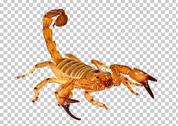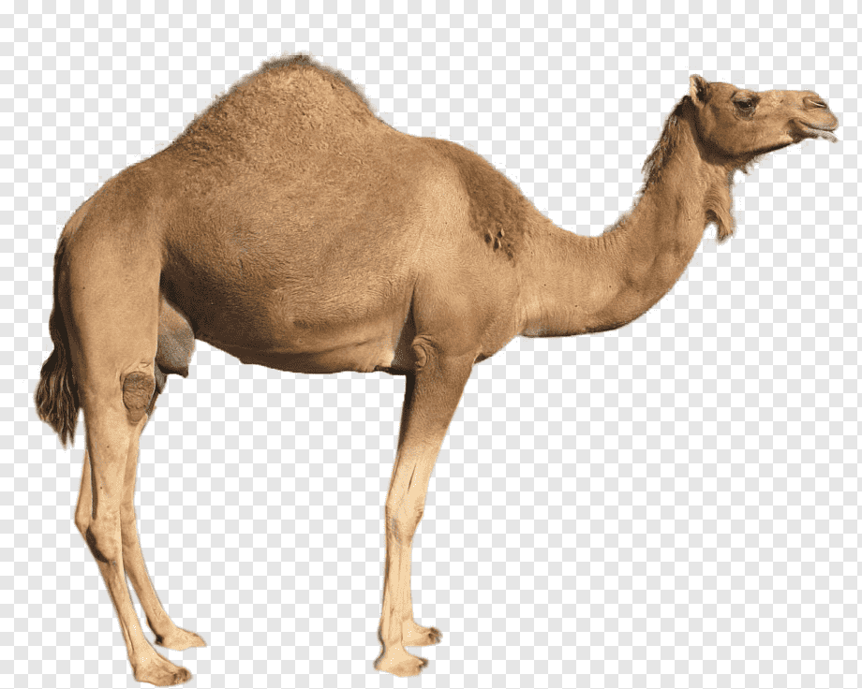**1. Name these animals that we can see in the desert area;**

……………………… …………………………….

**2. Name this film actor who had to face legal action for hunting the black buck?**



**………………………………**

**3. The people who kill animals for fun or their body parts are called….**

1. Protectors
2. Poachers
3. Laborers
4. None of the above

**4. Match the following animals with the parts they are killed.**

**Column A Column B**

1. Tiger (i) Ivory (Tusks)
2. Elephant (ii) Skin
3. Rhino (iii) Musk
4. Musk Deer (iv) Horns

**5. Look at the picture and answer the following question:**

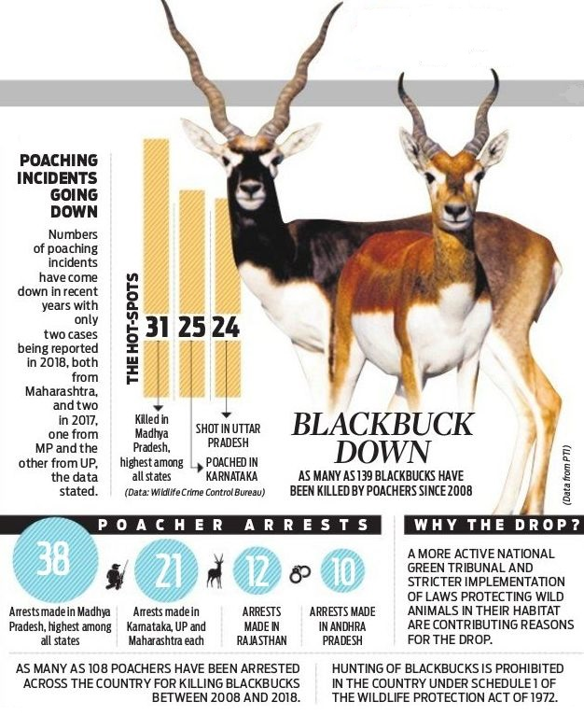

1. Name the animal that is shown in the picture. …………………….
2. Are the poaching incidents gone down in the recent years? Yes or No? ………………
3. Which of the following incident has the highest poaching incidents?
4. Karnataka (b) Uttar Pradesh (c) Rajasthan (d) Madhya Pradesh
5. In total, how many poachers have been arrested across the country for the killing blackbucks?
6. 139 (b) 21 (c) 38 (d) 108
7. Hunting of Blackbuck is prohibited in our country by which act?

……………………………………………………………….