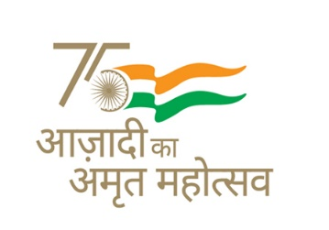 **KENDRIYA VIDYALAYA SANGATHAN AHMEDABAD REGION**

**GRADED WORKSHEET**

**CLASS : 4 SUBJECT: EVS LEVEL : 1**

**Concept : Family and Friends Max. Marks : 10**

**Name of the KV : _________________________________________________________**

**Name of the Student : ____________________ Roll No. ______ Section: _____**

**Date : ______________ Marks Obtained: _______ Sign of Teacher____________**

**Q.1. Find the insects you see around in word puzzle below and circle them –**

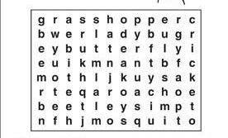

**Q 2. Circle the insects shown below which lives in group -**

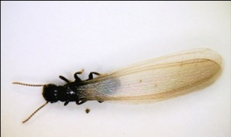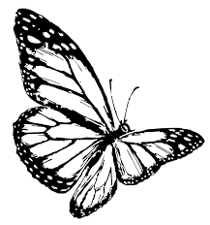 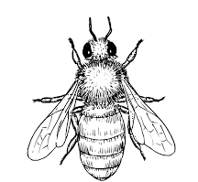 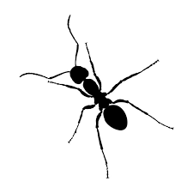

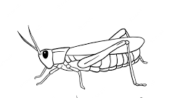 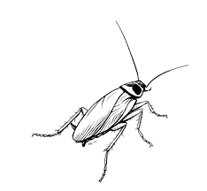

**Q3. Match the insect name with the things they do for us –**

**Honey bee gives us ________________**

**Silkworm gives us _________________**

**Q4. See the picture and answer the questions -**

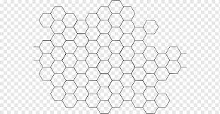

**a) What is this ? __________________________.**

**b) Which insect lives in it ? ___________________**

**Q5. a) How many types of honey bees live in bee hive ?**

**Ans - __________________________ .**

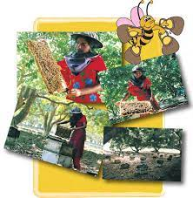**b) . Name the types of honey bee. _______________________________________________.**

**Q 6 Keeping and rearing Honey bees is called –**

**(a) Apiculture (b) Sericulture(c) Grazing)**

**Q 7. i). Litchi trees give flowers in the month of**

**(a) October (b)December (c) February**

**ii) Honeybees suck ___________ from the flowers.**

**(a) Water (b) sugar (c) nectar**

**Q 8 .i) There is _____________bee in a hive.**

**ii) Honeybees lay their eggs from _________ to ____________**

**Q. 9. The group of flowering trees is called**

**(a) Garden (b) Orchard (c) Field**

**Q. 10. Anita’s mother prepares ………………… syrup to feed baby Honey bees.**

 **KENDRIYA VIDYALAYA SANGATHAN AHMEDABAD REGION**

**GRADED WORKSHEET**

**CLASS : 4 SUBJECT: EVS LEVEL : 2**

**Concept : Family and Friends Max. Marks : 10**

**Name of the KV : _________________________________________________________**

**Name of the Student : ____________________ Roll No. ______ Section: _____**

**Date : ______________ Marks Obtained: _______ Sign of Teacher____________**

**ANSWER THE FOLLOWING QUESTIONS –**

**1. Name the insect shown in the image:**

**_________________________.**

**2. What does it makes ? __________________________ .**

**3. Name two other insects who live in group ? ________________ , _______________**

**4. Name the type of honey bee who do following work in hive -**

**i) lay eggs : ____________ ii) feed baby honey bees : ______________ .**

**5. Anita took training for which work or profession ?**

**_____________________________________________________________________.**

**6. Upto which standard Anita got free education or not paid the school fees ?**

**______________________________________**

**7. Who helped Anita in her work ?**

**_______________________________________________________________________.**

**8. What does Anita wants to tell to people in a meeting ?**

**Ans. She wants people to send their child to _______________**

**__________________________________________.**

 **KENDRIYA VIDYALAYA SANGATHAN AHMEDABAD REGION**

**GRADED WORKSHEET**

**CLASS : 4 SUBJECT: EVS LEVEL : 3**

**Concept : Family and Friends Max. Marks : 10**

**Name of the KV : _________________________________________________________**

**Name of the Student : ____________________ Roll No. ______ Section: _____**

**Date : ______________ Marks Obtained: _______ Sign of Teacher____________**

**Q. 1. Identify and name the type of Honey bee in given picture -**

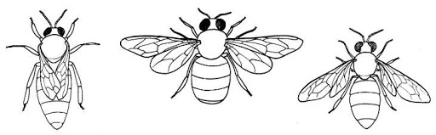**–**

**I) ______________ 2) __________________________ 3) ______________________**

**Q. 2. What does the male bee called as and what does it do in hive?**

**_____________________________________________________________________**

**_____________________________________________________________________**

**Q. 3. How does a worker bee inform other bees about flowers with nectar ?**

**_________________________________________________________________-**

**Q.4. What is applied at home to treat the Bee sting ?**

**______________________________________________________________________**

**Q. 5. Write two uses of honey .**

**___________________________________________________________________________**

**___________________________________________________________________________**

**Q. 6. Find out how much money do you spend in one year for various school related things. Fill the money spent part yourself.**

|  |  |  |
| --- | --- | --- |
| **S.no** | **Things** | **MONEY SPENT** |
| **1** | **Transportation** |  |
| **2** | **Note books** |  |
| **3** | **Pen-pencil/stationary** |  |
| **4** | **Uniform** |  |
| **5** | **School bag** |  |
| **6** | **Lunch box** |  |
| **7** | **shoes** |  |

**Ans ----------------------------------------------------------------------------------**

**KENDRIYA VIDYALAYA SANGATHAN AHMEDABAD REGION**

**GRADED WORKSHEET**

**CLASS : 4 SUBJECT: EVS LEVEL : 4**

**Concept : Family and Friends Max. Marks : 10**

**Name of the KV : _________________________________________________________**

**Name of the Student : ____________________ Roll No. ______ Section: _____**

**Date : ______________ Marks Obtained: _______ Sign of Teacher____________**

**ANSWER THE FOLLOWING QUESTIONS :-**

**1. Identify the state in which Anita Khushwaha lives shown below in the Indian political map –**

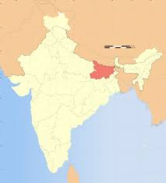

**State - ________________**

**District - ________________**

**Village - ___________________**

**2. Why she did not go to school in her early childhood and who helped her to go to school ?**

**___________________________________________________________________________**

**___________________________________________________________________________**

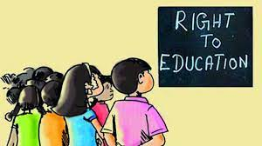**3. What does the Right To Education means as shown in the picture below due to which Anita completed her studies -**

**__________________________________________________**

**4. Why Anita is a ‘Girl Star’**

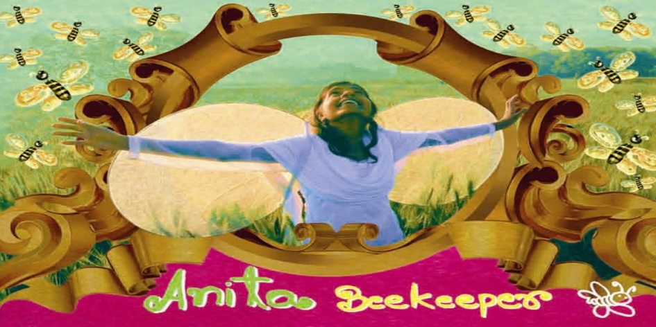

**_______________________________________________________________________**

**______________________________________________________________________**

**5. Draw a worker honey bee. From where do they get nectar?**

|  |
| --- |
|  |