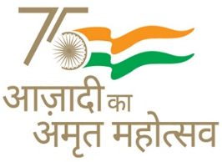
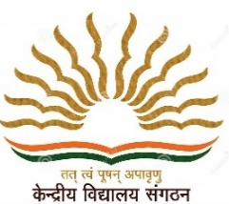
KENDRIYA VIDYALAYA SANGATHAN AHMEDABAD REGION
GRADED WORKSHEET
CLASS : 4 SUBJECT: EVS LEVEL : 3
Concept : Max. Marks : 10
Name of the KV : _________________________________________________________
Name of the Student : ___________________ Roll No. ______ Section: _____
Date : _______________ Marks Obtained: _________ Sign of Teacher____________
1. Observe the given picture and answer that what resembles with her mother.

__________________________________________________
2. Fill in the table on celebration of important days/festivals by ticking the Correct boxes (only one box in each row is to be ticked).
Name of the days/ festivals | Normally celebrated with family members and friends | Normally celebrated with teachers and classmates | May be celebrated at both places
Republic day
Holi
Diwali
Independence day
Christmas
Janmastami

3. What are the reasons to changes in family? Describe any two.
______________________________________________________________________________________________________________________________________________________

4. We all learn from our elders. What do you learn from your parents/ grandparents.
PASTE THE PHOTO OF YOUR FATHER
A.
____________________________________________________________________________________________
B. ______________________________________________________________________________________________________________
PASTE THE PHOTO OF YOUR MOTHER
C. ______________________________________________________________________________________________________________
PASTE THE PHOTO OF YOUR GRAND FATHER
D. ______________________________________________________________________________________________________________
PASTE THE PHOTO OF YOUR GRANDMOTHER

5. Make a list of festivals that you celebrate :
In School At home
________________ ________________
________________ ________________
________________ ________________
________________ ________________
6. According to marriage law what is the marriage age for :
For girls - ............................ For boys - .............................

KENDRIYA VIDYALAYA SANGATHAN AHMEDABAD REGION
GRADED WORKSHEET
CLASS : 4 SUBJECT: EVS LEVEL : 4
Concept : Max. Marks : 10
Name of the KV : _________________________________________________________
Name of the Student : ___________________ Roll No. ______ Section: _____
Date : _______________ Marks Obtained: _________ Sign of Teacher____________
1. What is the minimum age of girls for marriage?
_______________________________________________________________
2. What is the minimum age of boys for marriage?
_______________________________________________________________
3. Are there any such children in your neighbourhood who had to drop out of school? Do they want to go back to school? How do you help them?
____________________________________________________________________________________________________________________________________________________________________
4. If your father got promotion and get posting in another city, what is the feeling of the following persons?
a) You-____________________________
b) Mother -_________________________
c) Father-__________________________
d) Grand-father- _____________________
e) Grand-mother-_____________________

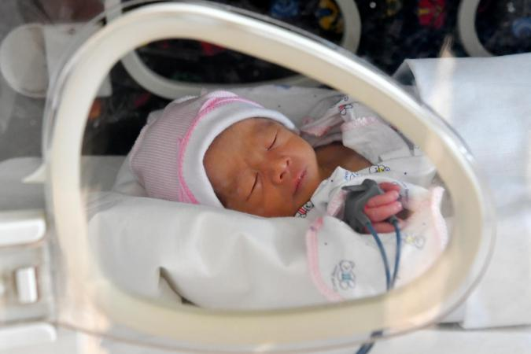
5. If a baby born in the family, what is the feeling of the following persons?

a) You - _____________________
b) Father - ____________________
c) Mother - ____________________

