KENDRIYA VIDYALAYA SANGATHAN AHMEDABAD REGION
GRADED WORKSHEET
CLASS : 3 SUBJECT: EVS LEVEL : 1
Concept : Family and Friends Max. Marks : 10
Name of the KV : __________________________________________________
Name of the Student : __________________ Roll No. ______ Section: _____
Date : __________ Marks Obtained: _______ Sign of Teacher ________
Observation and Reporting
A) Observe the following pictures of some animals and answer the following questions.
Q,1) Tick (√) the correct bird shown in the following picture.
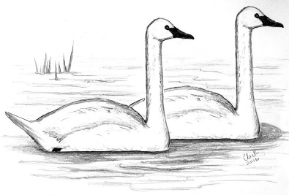
A) Duck B) Swan C) Crane
Q.2) Which animal has spots on its body.
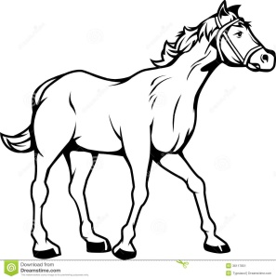( ) 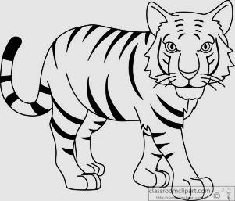 ( ) 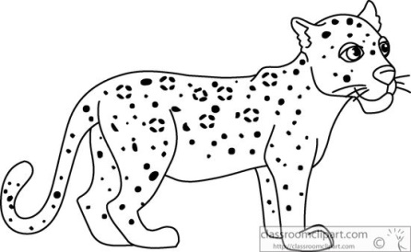 ( )
Q.3) among the following animals which animal has long ears?
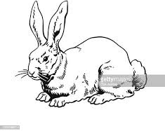( )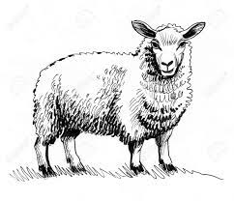 ( ) 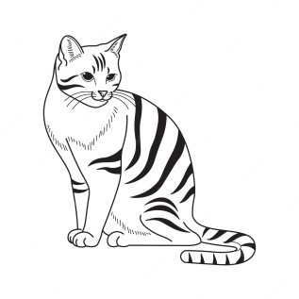( )

Identification and classification
B) Give answers:
Q.4) Tick the animal which can swim in water.
A) Crocodile B) Monkey C) Goat
Q.5) Tick the animal which has wings.
A) Snake B) Cow C) Pigeon
Q.6) Among the following birds which bird can fly?
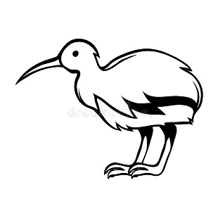 ( ) 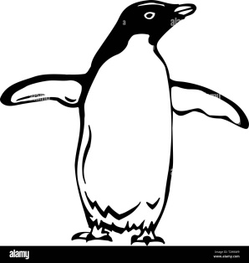 ( ) 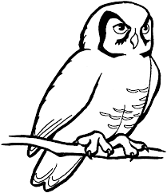( )
Ans: __________________
Discovering of Facts
C) Find answers of the following questions in the following crossword grid.
 | 1
1 |  | 2
 |  | 2
Down
Q.7) An animal remains awake the whole night.
Q.8) A bird that can fly very high.
Across
Q.9) An animal which has ears like fans.
Q.10) An animal that lives in family groups.

KENDRIYA VIDYALAYA SANGATHAN AHMEDABAD REGION
GRADED WORKSHEET

CLASS : 3 SUBJECT: EVS LEVEL : 2
Concept : Family and Friends Max. Marks : 10
Name of the KV : __________________________________________________
Name of the Student : __________________ Roll No. ______ Section: _____
Date : __________ Marks Obtained: _______ Sign of Teacher ________
AnimalsObservation and Reporting
Q.1 Draw missing body parts of the following animals.
Q.2 Draw missing body parts of the following animals.
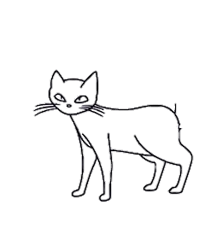
Identification and classification
Q.3 Below pictures shows the body parts of different animals. Tick (√) the wings.
( ) ( ) 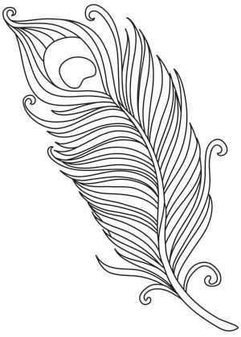( )
Q.4 Tick the animal which lives only in water.
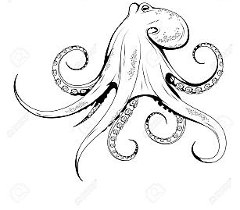( ) ( ) 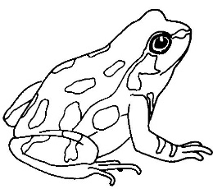 ( )
Q.5 Match the following animals with their movement.
Rabbit Walks
Cow Swims
Fish Crawls
Lizard hops
Discovering of Facts
Q.6 What does a cat say?
(a) Mooo-mooo (b) Baa-baa (c) meow-meow
Q.7 Which bird does have feathers on its body?
(a) penguin (b) Kiwi (c) Pigeon
Q. 8. Write the names of any two animals which lay eggs.
Ans: 1) ________________________
2) ________________________

KENDRIYA VIDYALAYA SANGATHAN AHMEDABAD REGION
GRADED WORKSHEET

CLASS : 3 SUBJECT: EVS LEVEL :3
Concept : Family and Friends Max. Marks : 10
Name of the KV : __________________________________________________
Name of the Student : __________________ Roll No. ______ Section: _____
Date : __________ Marks Obtained: _______ Sign of Teacher ________
Observation and Reporting
Q.1 Among the following which animal does not have fur on its body? (Tick)
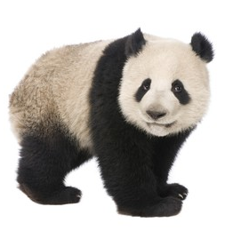 ( ) 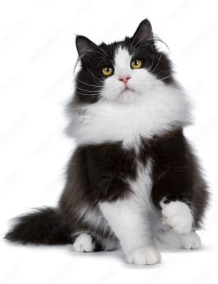 ( )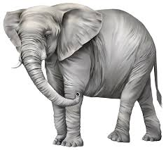( )
Q.2 Among the following which animal is used to carry our loads? (Tick)
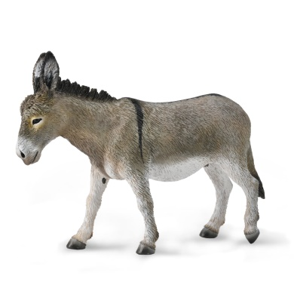 ( )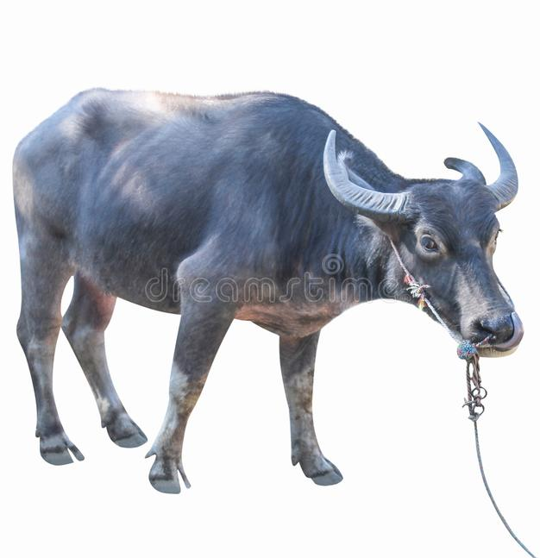 ( )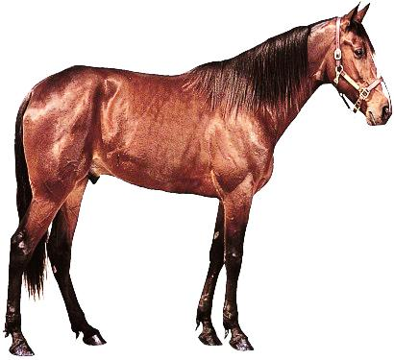 ( )

dentification and classification
Q.3 Write names of any two animals who have a long tail.
Ans: __________________ : __________________
Q.4 Write names of any two animals who have furry tail.
Ans: __________________ : __________________
Discovering of Facts
CROSSWORD
B | E | E | S | E | C | K | I | B | G
X | E | L | E | P | R | A | N | I | O
F | O | O | P | M | O | N | Z | R | R
I | X | Z | T | O | C | G | E | D | R
S | N | T | W | N | O | A | B | S | I
H | O | X | U | K | D | R | R | E | L
C | A | T | O | E | I | I | G | E | R
L | I | O | N | Y | L | O | P | Z | Q
Z | E | B | R | A | E | B | E | A | R
Q.5 From the above crossword find the name of the animals that live in groups.
Ans: 1)
2)
Q.6 From the above crossword find the name of the animals that live in water.
1)
2)

KENDRIYA VIDYALAYA SANGATHAN AHMEDABAD REGION
GRADED WORKSHEET
CLASS : 3 SUBJECT: EVS LEVEL : 4
Concept : Family and Friends Max. Marks : 10
Name of the KV : __________________________________________________
Name of the Student : __________________ Roll No. ______ Section: _____
Date : __________ Marks Obtained: _______ Sign of Teacher ________
Observation and Reporting
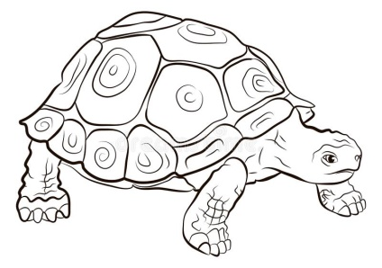
Q.1 You have seen following animals around you. Their pictures are given in same size. You have to write their names according to their actual size (small to big).
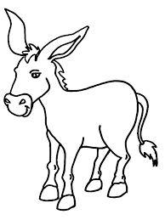

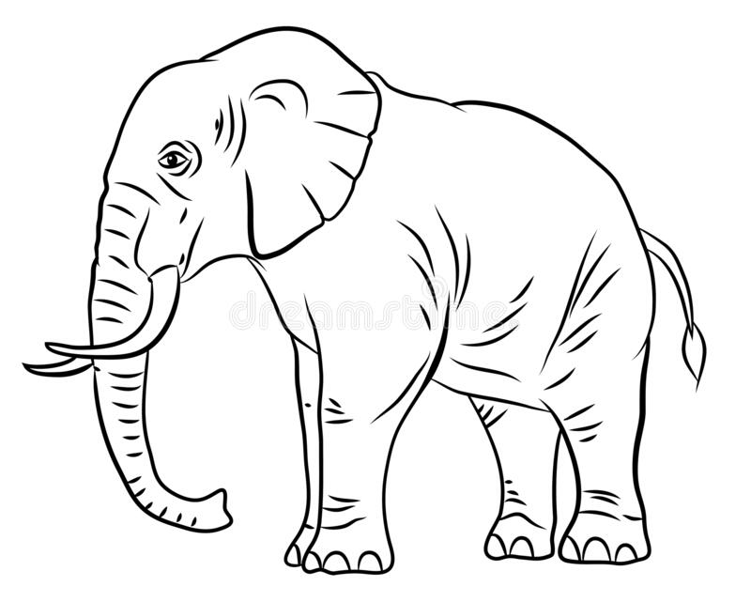

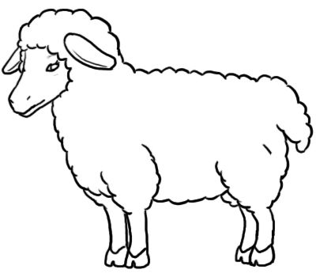

Ans: 1. ____________
2. ____________
3. ____________
4. ____________
Identification and classification
Q.2 Classify the following animals into two following groups.
Hen Cow Bat Dog
Animals which lay eggs: | Animals which give birth to their babies.
Q.3 Match the following.
Animal Cock
Bird Snake
Reptile Whale
Fish Hare
Discovering of Facts
Q.4 Find the following facts about the elephant by selecting the correct option.
- The elephant lives in _____________. (Desert / Water / Forest)
- It eats __________________. (Grass and plants / Flesh of other animals)
- It ________________. (Trumpets / Chatters / roars)
- We can ride on it. _________. (True / False)
- It carry our loads. _________. (True / False)
Q.5 Write the name of the following animals.
(a) The biggest bird in the world. _______________
(b) The biggest sea animal in the world. _______________
(c) The biggest forest animal in the world. _______________
(d) The smallest bird in the world. _______________

