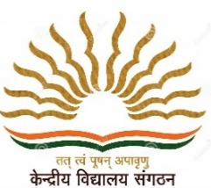
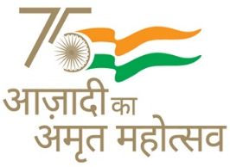
KENDRIYA VIDYALAYA SANGATHAN AHMEDABAD REGION
GRADED WORKSHEET
CLASS : 3 SUBJECT: EVS LEVEL : 1
Concept /Theme: Food Max. Marks : 10
Name of the KV :_______________________________________________________

Name of the Student : ___________________________Roll No. ______ Section: ___

Date : _______________ Marks Obtained: _________ Sign of Teacher________

1. Encircle the utensils used in olden days:
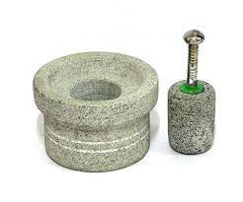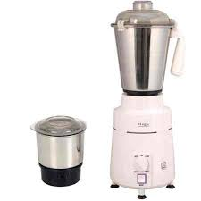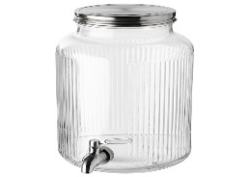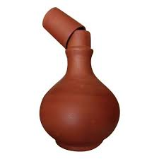
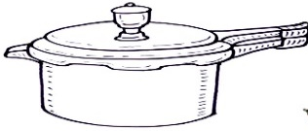
2. Match the utensils with their name:
- Spatula
- tongs
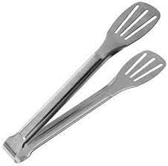
- pressure cooker
3. Classify and name the food items given in the box under suitable headings in the table given below:
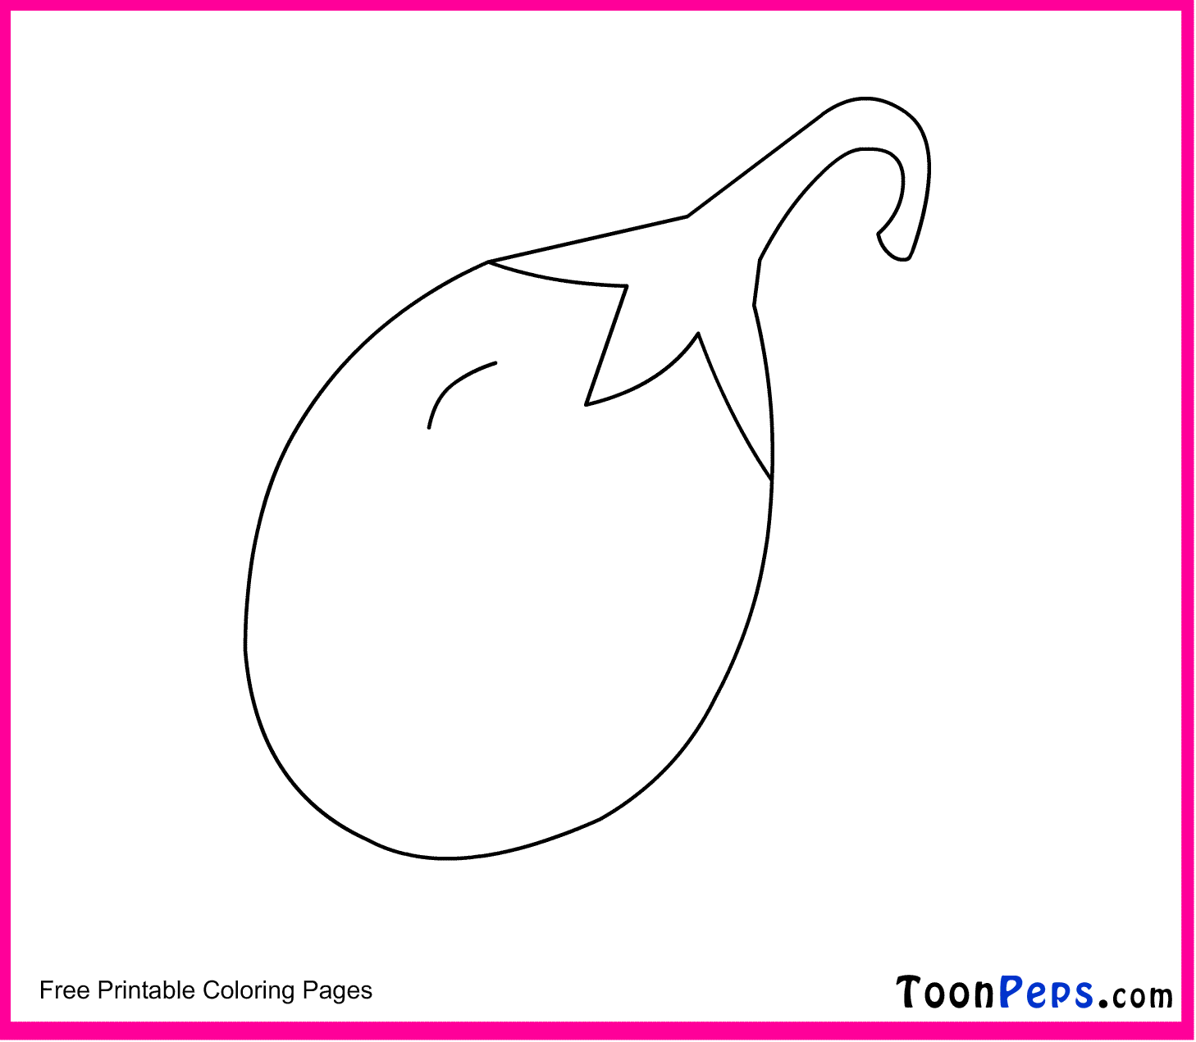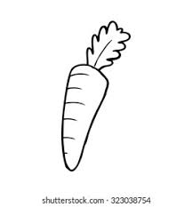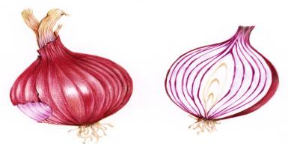

S.NO | Food items that can be eaten both raw and cooked | Food items that can be eaten only after being cooked

4. Many types of fuel are used in cooking . Name the fuel used in the given picture. Choose the answers from the help box given below:
Electricity , Solar Energy, Wood , LPG

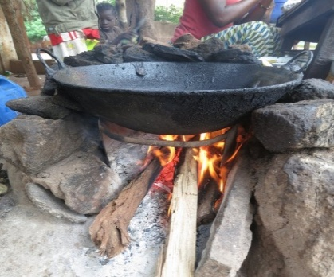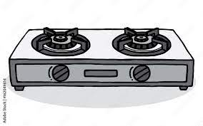
____________________ ___________________________
5. Observe the food items given and write the method by which it is cooked. Choose the answers from the help box given below:
Frying , Roasting , Baking , Boiling

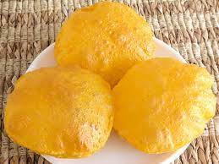
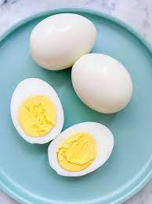
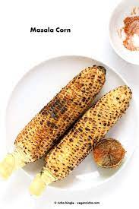
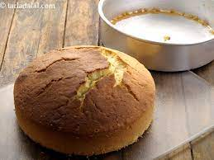

_____________ _______________ _______________ ______________
6. Name a few eatables made from rice.
Ans. ………………………………………………………………………………………………………………………………..
7. Name the food items that we get from animals.
Ans. ………………………………………………………………………………………………………………………………..
8. Old people prefer to have Daliya. Why?
Ans. ………………………………………………………………………………………………………………………………..
9. Why do we soak chana and then cook it?
Ans. ………………………………………………………………………………………………………………………………..
10. In which month wheat is harvested?
Ans. ………………………………………………………………………………………………………………………………..

