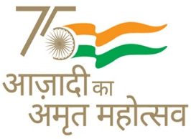
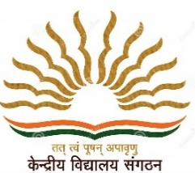
KENDRIYA VIDYALAYA SANGATHAN AHMEDABAD REGION
GRADED WORKSHEET
CLASS : 3 SUBJECT: EVS LEVEL : 1
Concept /Theme: Things We Make and Do Max. Marks : 10
Name of the KV : _________________________________________________________
Name of the Student : ___________________________Roll No. ______ Section: _____
Date : _______________ Marks Obtained: _________ Sign of Teacher____________
1. Observe the pictures given below and write the work they do from the help box given :
Delivers mail , selling vegetables , Making pots

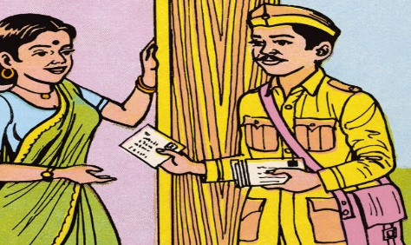
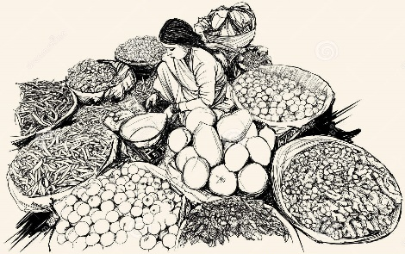
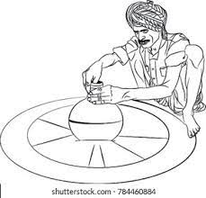
____________________ ___________________ _______________________

2. Observe the picture and put a tick mark in the box on the work you do .

- 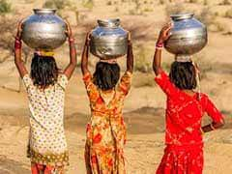 2. 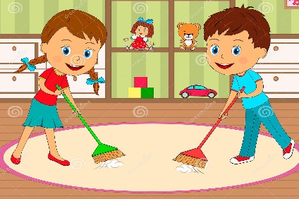 3. 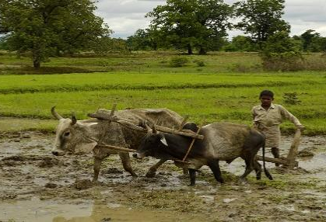

4. 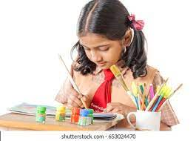 5. 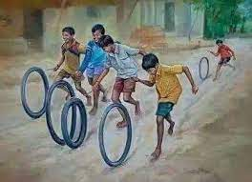 6. 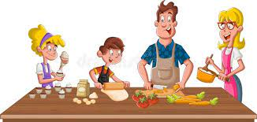

3. Name your family members and write any one work done by them :
S.NO | NAME OF FAMILY MEMBER | RELATIONSHIP WITH YOU | WORK DONE

4. Name some public places.
Ans. …………………………………………………………………………………………………………………………………
5. Who are called our helpers?
Ans. ………………………………………………………………………………………………………………………………..
………………………………………………………………………………………………………………………………………..
6. What are the things that we get from post office?
Ans. ………………………………………………………………………………………………………………………………..
7. At the time of emergency (health) who looks after you?
Ans. ……………………………………………………………………………………………………………
8. During Covid-19 whose advise we used to follow to keep ourselves healthy?
Ans. ……………………………………………………………………………………………………………
9. Which no. we dial during emergency of health?
Ans. ……………………………………………………………………………………………………………
10. What is the role of a teacher in your life?
Ans. ……………………………………………………………………………………………………………

