KENDRIYA VIDYALAYA SANGATHAN AHMEDABAD REGION
GRADED WORKSHEET
CLASS : 3 SUBJECT: EVS LEVEL : 1
Concept : Family and Friends Max. Marks : 10
Name of the KV : __________________________________________________
Name of the Student : __________________ Roll No. ______ Section: _____
Date : __________ Marks Obtained: _______ Sign of Teacher ________
Observation and Reporting
A) Observe the following pictures of some animals and answer the following questions.
Q.1) Below pictures are of the different types of plants. Tick (√ ) the Tree.
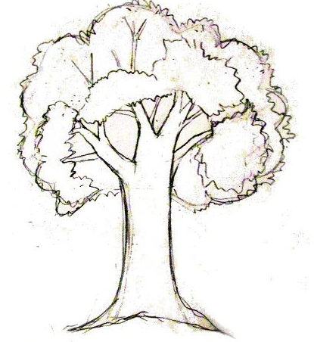 ( ) 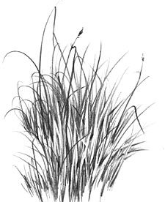 ( )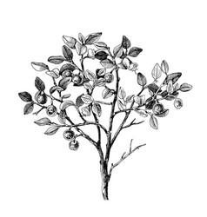 ( )
Q.2) Which part of the plant grows underground? Tick (√ )
(a) Leaves ( ) (b) Fruits ( ) (c) Roots ( )
Q.3) Tick the rose flower.
( )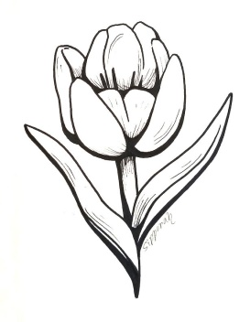 ( ) 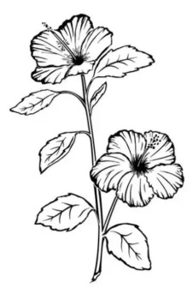 ( )
Identification and classification
Q.4 Which plant does not have small leaves.
(a) Banana (b) Mint (c) Drumstick
Q.5 Draw a people leaf and colour it.

Q.6 Pick the odd one out.
(a) Mango (b) Lily (c) grass (f) fish
Discovering of Facts
Q.7 Write the name of two plants which have long leaves.
Ans: a) ____________________
b) ____________________
Q.8 Write the names of two plants which does not have the woody stems.
Ans: a) ____________________
b) ____________________
Q.9 Write the names of any two plants which have trunks.
Ans: a) ____________________
b) ____________________
Q.10 Write the names of any two trees which bear fruits.
Ans: a) ____________________
b) ____________________

KENDRIYA VIDYALAYA SANGATHAN AHMEDABAD REGION
GRADED WORKSHEET
CLASS : 3 SUBJECT: EVS LEVEL : 2
Concept : Family and Friends Max. Marks : 10
Name of the KV : __________________________________________________
Name of the Student : __________________ Roll No. ______ Section: _____
Date : __________ Marks Obtained: _______ Sign of Teacher ________

Q.1) Among the following leaves tick the Neem tree leaf.
Q.2) Draw grass and colour it.

Identification and classification
Q3) Pick the odd one out.
(a) Mango (b) Mint (c) Banyan (d) Fish

Q.4) Label the part of the leaf given below..
Q.5) Classify the following plants into two following groups.
Pumpkin Grapes Peas Watermelon
Which grows on the ground | Which grows by climbing on the another plants

Discovering of Facts
Q.6) Among the following which plant bear long fruits?
A) Lotus B) Cactus C) Lemon D) Drumstick
Q,7) Write the name of any two trees which doesn’t bear fruits.
- ___________________
- ___________________
Q.8) Draw a plant and label its parts.

KENDRIYA VIDYALAYA SANGATHAN AHMEDABAD REGION
GRADED WORKSHEET
CLASS : 3 SUBJECT: EVS LEVEL : 3
Concept : Family and Friends Max. Marks : 10
Name of the KV : __________________________________________________
Name of the Student : __________________ Roll No. ______ Section: _____
Date : __________ Marks Obtained: _______ Sign of Teacher ________
Observation and Reporting
Q.1) Tick the cactus plant.
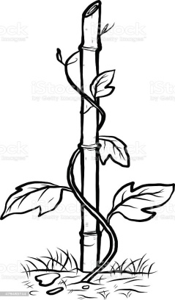( ) 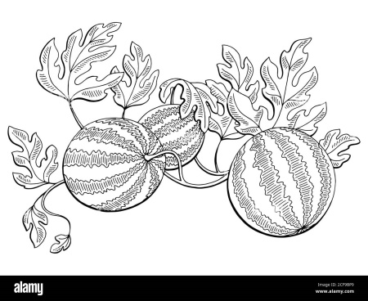( ) 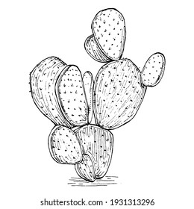( )
Q.2) Among the following which plant has very big leaves.
(a) Mango (b) drumstick (c) Coconut
Identification and classification
Q.3) Classify the following plants into herbs and shrubs.
Tulsi Rose Heena (Mehandi) Mint
- Herbs: ________________ _________________
- Shrubs: ________________ _________________
Q.4) Write shape of each leaves from the options given below.
(heart shaped, needle, Hand shaped, round)
_____________ ___________ ___________ ____________
Discovering of Facts
Q.5) Discover the things that a plant needs to grow.
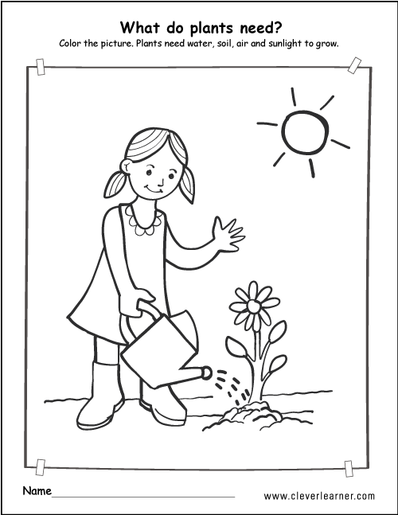
S __ __ __
A __ __
W __ __ __ __
S __ __ __ __ __ __ __
Q.6) The pictures of the stages of seed germination are in the wrong order. Give them correct order by labelling numbers 1 to 5.
KENDRIYA VIDYALAYA SANGATHAN AHMEDABAD REGION
GRADED WORKSHEET
CLASS : 3 SUBJECT: EVS LEVEL : 4
Concept : Family and Friends Max. Marks : 10
Name of the KV : __________________________________________________
Name of the Student : __________________ Roll No. ______ Section: _____
Date : __________ Marks Obtained: _______ Sign of Teacher ________
Observation and Reporting
Q.1) Draw a grape vine plant and colour it.

Identification and classification
Q.2 Classify the following flowers into following two groups.
Rose Lotus Lily Tulip
Grows in water: ___________________ ___________________
Grows on soil: ___________________ ___________________
Q.3 Identify the colours of the following flowers.
Sunflower: _____________________
Marigold: _____________________
Discovering of Facts
Q.4 Why banana plant is a herb not a tree?
Ans:________________________________________________________________________________________________________________________________________
Q.5 Write the names of any two plants which have woody stem.
Ans: 1) _____________________________ _
2) _____________________________ _

