

KENDRIYA VIDYALAYA SANGATHAN AHMEDABAD REGION
GRADED WORKSHEET
CLASS : 3 SUBJECT: EVS LEVEL : 1
Concept : Family and Friends Max. Marks : 10
Name of the KV : _____________________________________________________
Name of the Student : ____________________ Roll No. ______ Section: _____
Date : _________ Marks Obtained: ____ Sign of Teacher____________
Q.1 Where do you live ?
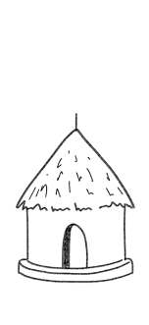
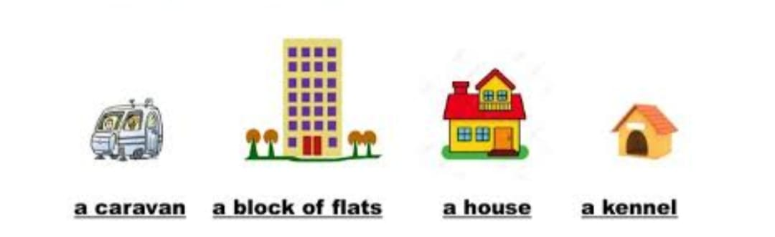 a hut
Ans. I live in ____________.
It is a pucca house / kuchha house.

Q:2 Write the numbers against the picture. ( any five)
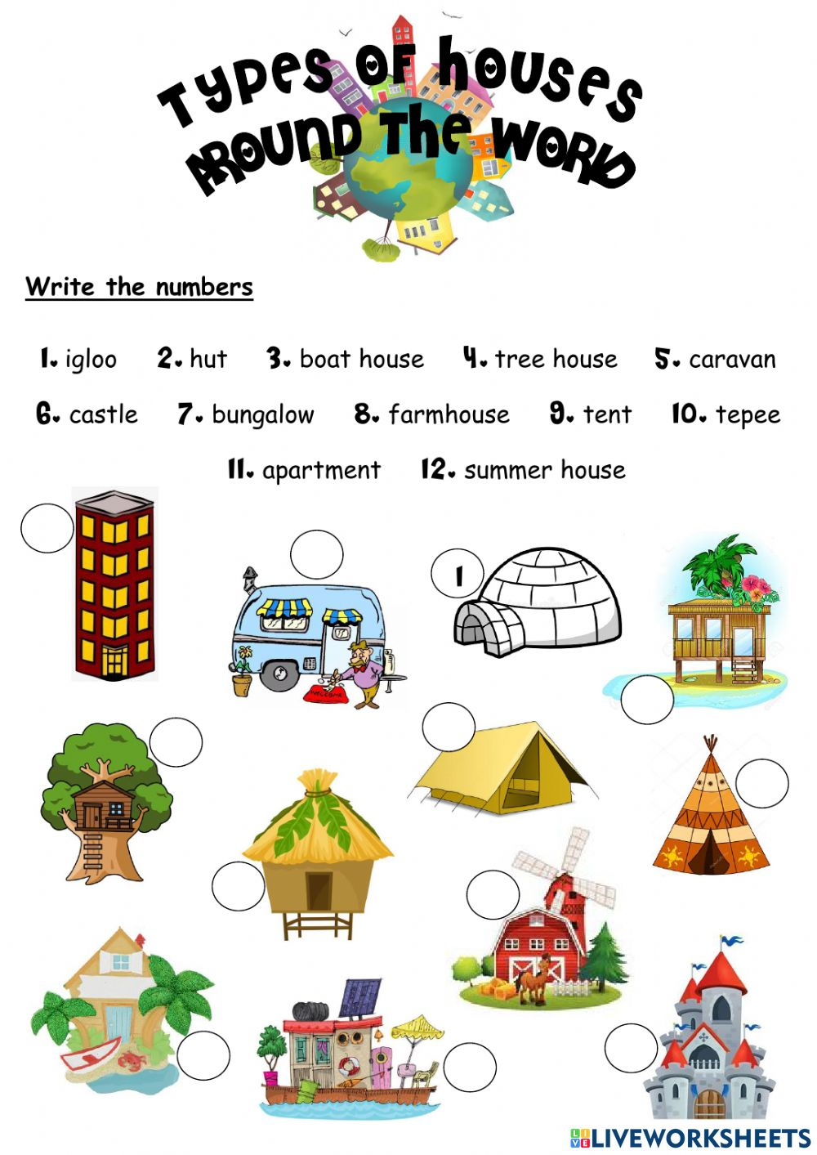

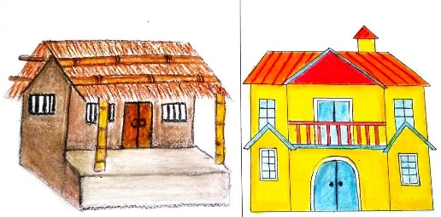
Q: 3 Pucca house is made up of ___________

- Mud b. bricks

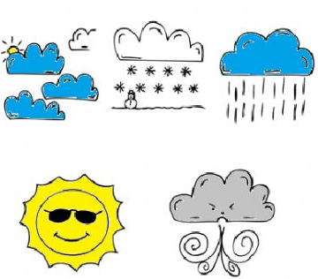
Q: 4 A house protects us from heat , ___________ ,__________and _______________

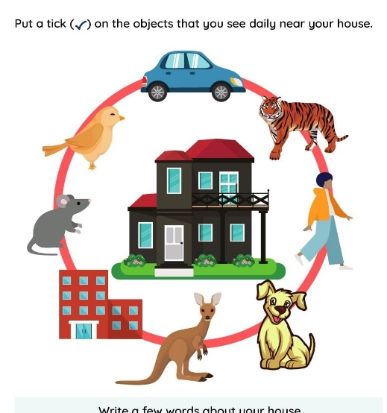
Q: 5 Put a tick ( )on the objects that you see daily near your house.

Q: 6 What is your reaction if you see a tiger around your house? Why ?


Ans :_____________________________________________________________________
Q. 7. What all things can be used to make a house from best out of waste?
Ans. _____________________________________________________________________________
Q. 8. What objects will you use to protect yourself from heavy rains?
Ans. _____________________________________________________________________________
Q. 9. Which place do you like the most for staying and with whom?
Ans. _________________________________________________________________________
Q. 10. A house with lot of trees are called …………………………………..

KENDRIYA VIDYALAYA SANGATHAN AHMEDABAD REGION
GRADED WORKSHEET
CLASS : 3 SUBJECT: EVS LEVEL : 2
Concept : Family and Friends Max. Marks : 10
Name of the KV : _____________________________________________________
Name of the Student : ____________________ Roll No. ______ Section: _____
Date : _________ Marks Obtained: ____ Sign of Teacher____________
Q:1 Why do we need shelter ? Do animals also have house ?
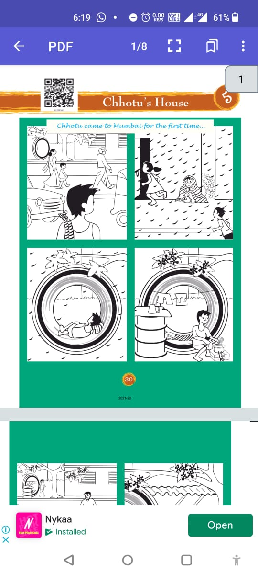

Ans : __________________________________ ______________________________________
______________________________________
______________________________________
______________________________________

A house is made of of different things. These things are name in the word grid given below.

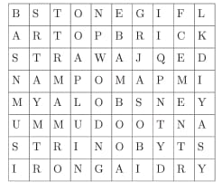
Q. 2. Name the materials required to make a house from the grid.
Ans : _________________________
_______________________________
____________________________________________________________________________________________________________________________

Q. 3. Now classify them into:
Things needed to build a kaccha house | Things needed to build a pucca house

Q. 4. Match animals with their home.
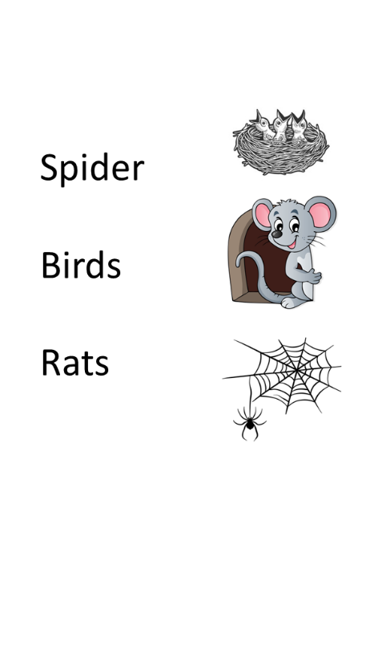

Q. 5. Can you tell where do lizards live?
Ans : __________________________ __________________________

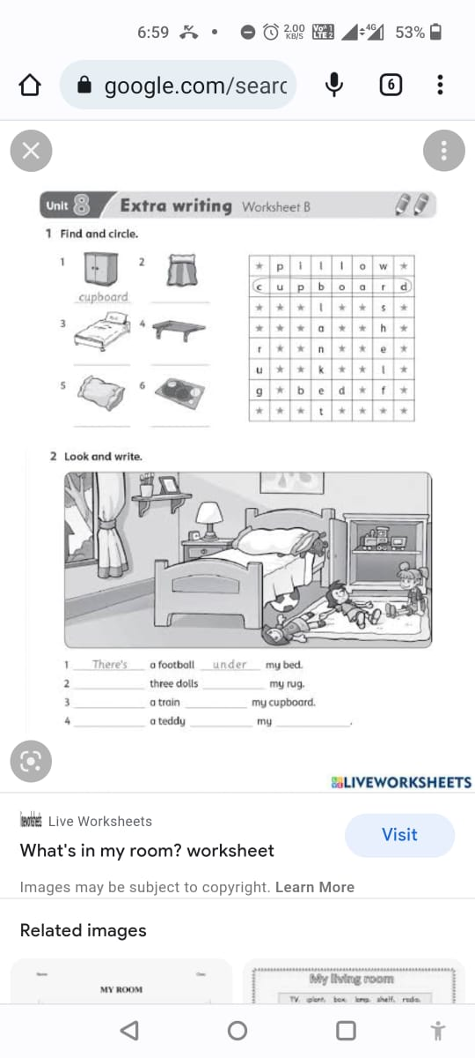
Observe and fill in the blanks.

- 6. Do you like an untidy room? Why?
Ans __________________________________
- 7. Who does the cleaning job in your house?
Ans __________________________________
Q.8. Which objects are used for sweeping and mopping the floor of your house?

KENDRIYA VIDYALAYA SANGATHAN AHMEDABAD REGION
GRADED WORKSHEET
CLASS : 3 SUBJECT: EVS LEVEL : 3
Concept : Family and Friends Max. Marks : 10
Name of the KV : _____________________________________________________
Name of the Student : ____________________ Roll No. ______ Section: _____
Date : _________ Marks Obtained: ____ Sign of Teacher____________
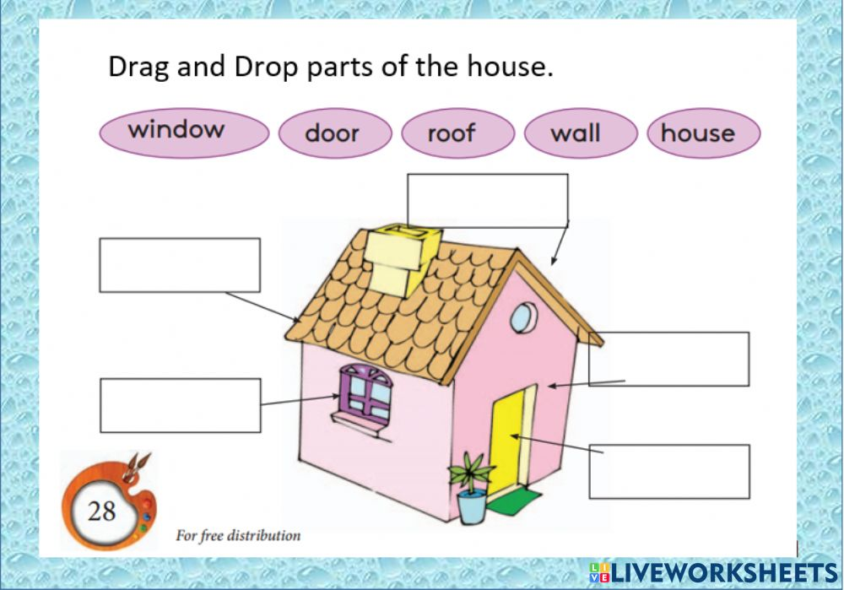
Q:1 Label the parts of house.
Q. 2. When do you decorate your house ? Name some occassions or festivals you decorated your house.
Ans : _____________________________________________________________________________________
_______________________________________________________________________________________
Q. 3. Circle the odd one out. Hint (You can take help from above picture )
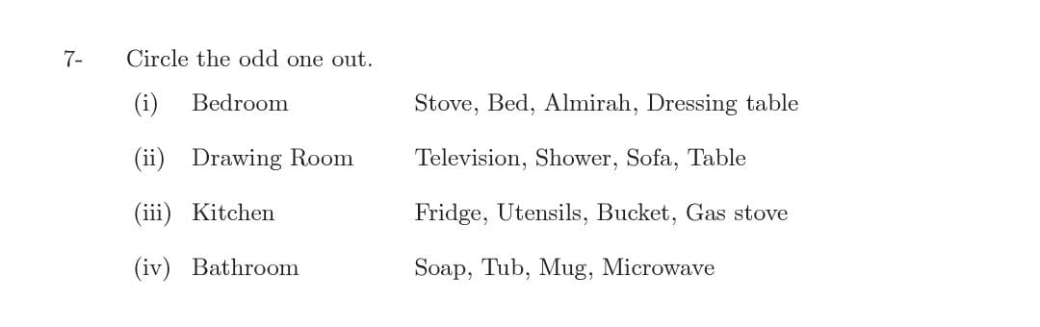

Q. 4. Mathch the words with the picture.
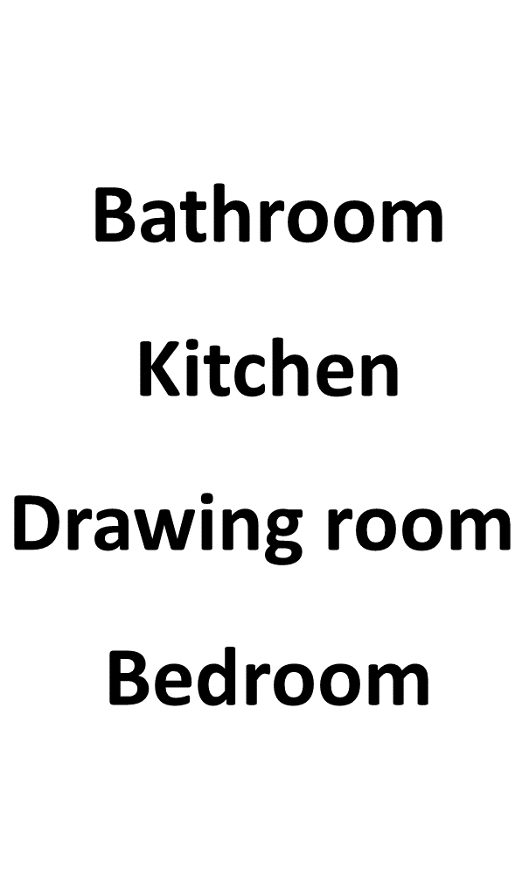
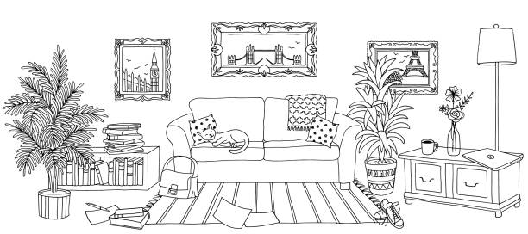

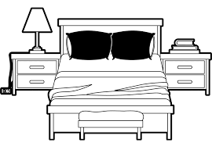
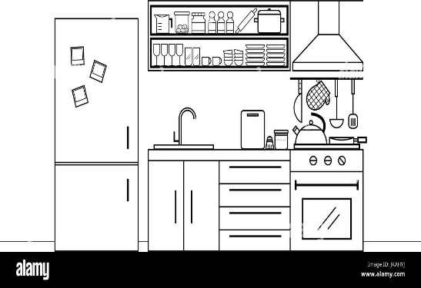

Q. 5. Look at the picture and tick the room of your choice.
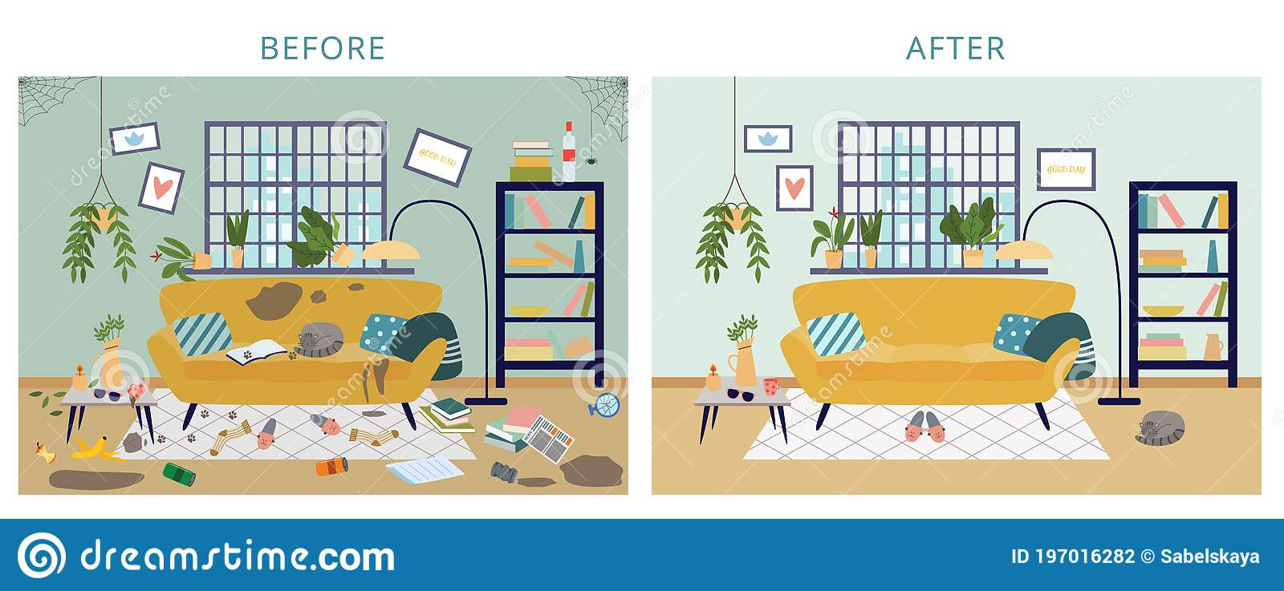

Q. 6. Draw the picture of any two animals that live in our house uninvited. Wrrite theire names below the picture.

KENDRIYA VIDYALAYA SANGATHAN AHMEDABAD REGION
GRADED WORKSHEET
CLASS : 3 SUBJECT: EVS LEVEL : 4
Concept : Family and Friends Max. Marks : 10
Name of the KV : _____________________________________________________
Name of the Student : ____________________ Roll No. ______ Section: _____
Date : _________ Marks Obtained: ____ Sign of Teacher____________
Q : 1 For a healthy living a good house should have the following qualities. Write Yes if you feel it is a necessary quality or NO, If you do not feel so.
- Multistory
- Proper Sanitation
- Pucca House
- Proper Ventilation
- Big in size

Q:2 Read and answer the questions.
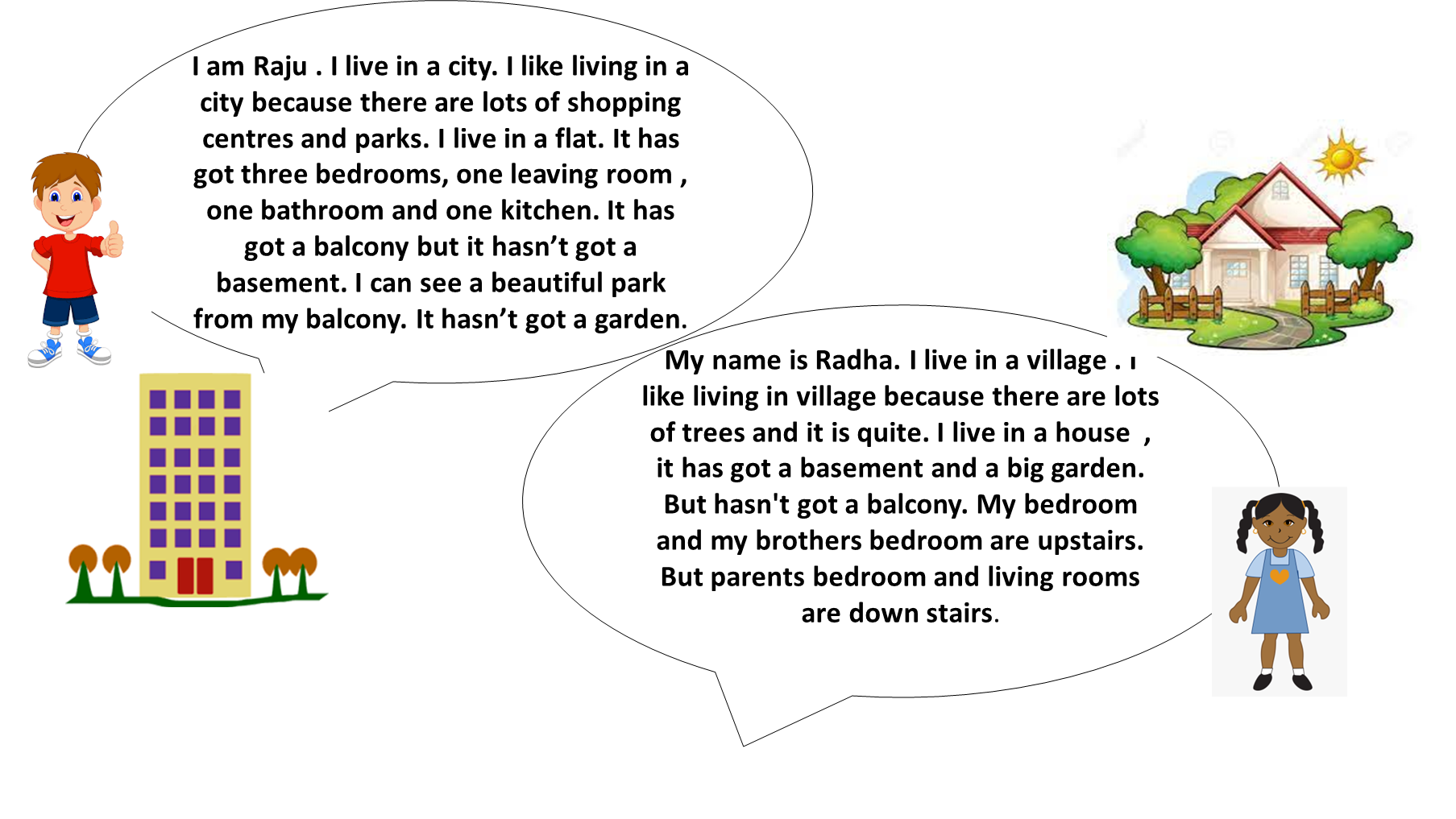

- Where does Raju live ?
Ans : ________________________________________________________________________

- Where does Radha live ?
Ans : ________________________________________________________________________

- What is the difference between in the house of Raju and Radha ?
Raju’s House | Radha’s House

- Which is your favorite house and Why?
Ans : ____________________________________________________________________
______________________________________________________________________________________________________________________________________________________________________________________________________________________
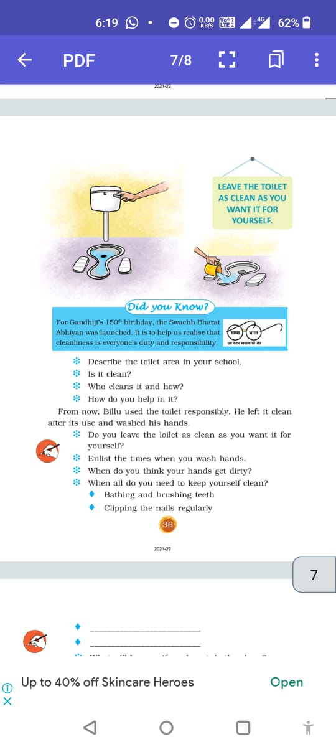
Q. 5. Write your views that Why do we keep our house and surrounding clean.
Ans : _________________________________________
_______________________________________________
_______________________________________________
_______________________________________________
_______________________________________________

