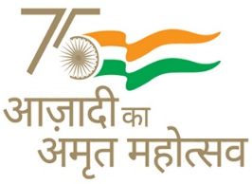
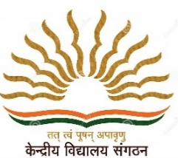
KENDRIYA VIDYALAYA SANGATHAN AHMEDABAD REGION
GRADED WORKSHEET
CLASS : 3 SUBJECT: EVS LEVEL : 1
Concept /Theme: Water Max. Marks : 10
Name of the KV : _________________________________________________________
Name of the Student : ___________________________Roll No. ______ Section: _____
Date : _______________ Marks Obtained: _________ Sign of Teacher____________

1.Observe the picture and match it with the sources of water given :
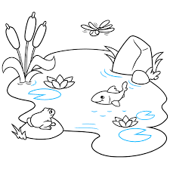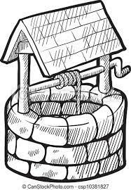

Sea
Well
Hand pump
Rain
Pond
River
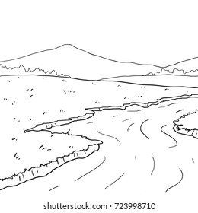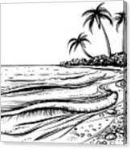
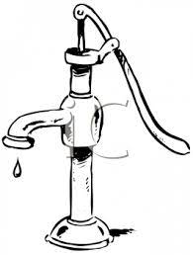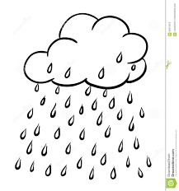
2.Observe the pictures given below and Encircle the objects that needs water. (2) 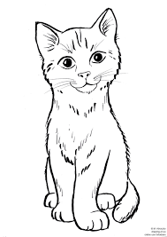 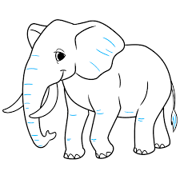 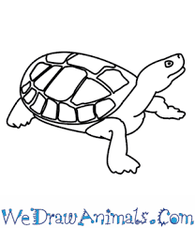
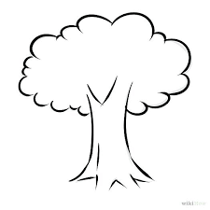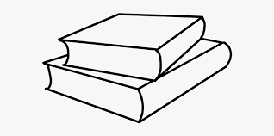
3. Observe the picture given below : Apart from clouds write down what else can you see during rainy season.
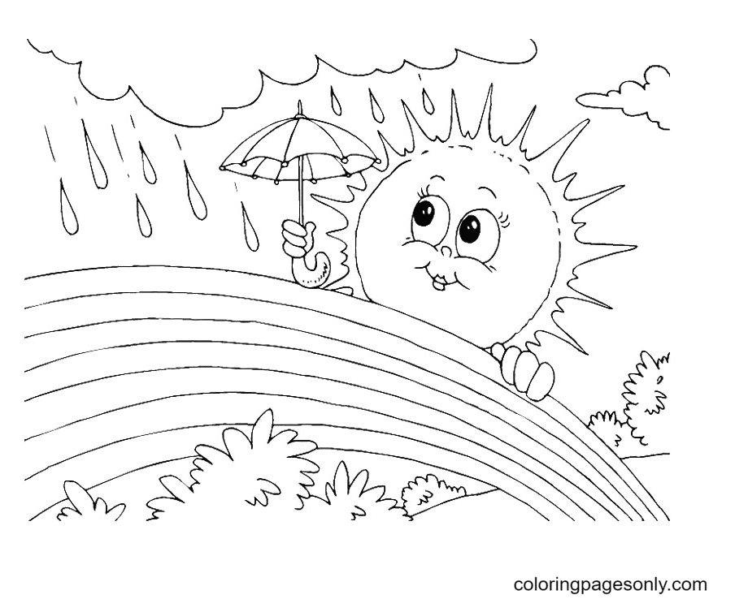
____________________________________________________________________
4. In picture A the boy is watering the plants. From where do the trees in Picture B gets water.
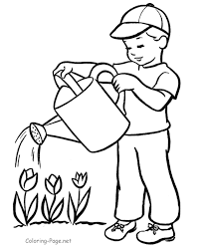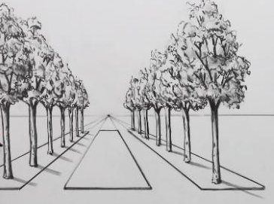
A B ____________________________________________________________________
____________________________________________________________________

5. In picture A the man is giving water to the horse. From where do the elephants living in jungle ( Picture B) drinks water?
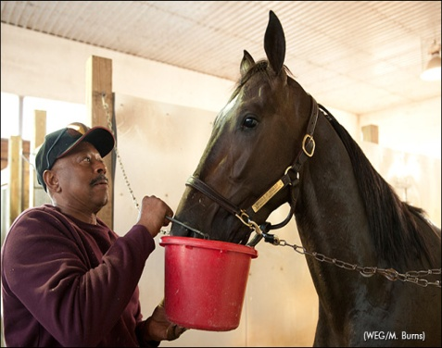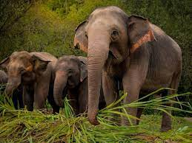
A B
6. How rainbow is formed?
____________________________________________________________________________
7. Name the city which receives highest rainfall in India.
__________________________________________________________________________
8. Draw a rainbow.

9. How many colours a rainbow has?
Ans. _______________________________________________________
10. How do you feel when it rains?
Ans. ___________________________________________________________

